# Module 1

## Introduction to Deep Learning and Neural Networks

## 📌Introduction to Deep Learning

Deep learning is a powerful and fast-evolving field within data science that enables machines to perform tasks previously thought to require human intelligence. Its ability to learn directly from raw data and discover intricate patterns has led to major breakthroughs in various domains.

Key strengths of deep learning models:

* Learn hierarchical representations automatically from data.
* Generalize effectively to unseen, real-world tasks.
* Handle unstructured inputs such as images, text, and audio.

### 🔹Real-World Applications of Deep Learning

Several current applications demonstrate the practical capabilities and versatility of deep learning models.

**🖼 Color Restoration**

* Grayscale images are transformed into colored versions using **convolutional neural networks (CNNs)**.
* The system learns color patterns from large datasets and applies them to monochrome input.
* Useful for enhancing historical media or generating stylized imagery.

**🗣 Speech Enactment**

* Deep learning models can synthesize audio with video by aligning lip movements with speech.
* A system built using **recurrent neural networks (RNNs)** enables realistic speech-video generation.
* This technology has been applied to create natural-looking speech reenactments from mismatched audio and video inputs.

**✍ Handwriting Generation**

* **RNNs** are also used to convert typed messages into lifelike cursive handwriting.
* The system can replicate different handwriting styles, either randomly or through user selection.
* Demonstrates the generative capabilities of sequence models.

### 🔹Additional Notable Use Cases

Beyond the highlighted examples, deep learning has enabled solutions in a wide range of tasks:

* **Automatic Machine Translation**: Translating text in real time, including text embedded in images.
* **Sound Generation**: Adding synchronized soundtracks to silent video based on scene context.
* **Image Classification and Object Detection**: Identifying objects and classifying them into categories.
* **Self-Driving Vehicles**: Processing sensor and visual data to navigate and make decisions autonomously.
* **Conversational AI**: Powering dynamic, context-aware chatbots.
* **Text-to-Image Generation**: Creating images based on natural language prompts using generative models.

### ✅ Takeaways

✅ Deep learning has rapidly advanced into a critical area of modern AI, enabling tasks that go beyond the reach of traditional machine learning.

✅ These models are especially effective in domains involving vision, audio, and language—where they outperform hand-engineered approaches.

✅ The core architecture behind these applications is the **neural network**, which will be explored in detail throughout this module.

## 📌Neurons and Neural Networks

### 🔹Biological Neurons: Structure and Function

Deep learning algorithms are fundamentally inspired by the structure and functioning of neurons in the human brain. Understanding how biological neurons operate helps provide context for the architecture of artificial neural networks.

**🧠 Components of a Neuron:**

* **Soma**: The main body of the neuron that contains the nucleus. It processes the incoming signals.
* **Dendrites**: Branch-like structures that receive electrical impulses (signals) from other neurons.
* **Axon**: A long fiber that transmits the processed signal away from the soma.
* **Synapses (or terminal buttons)**: Located at the end of the axon, they pass the output signal to the dendrites of neighboring neurons.

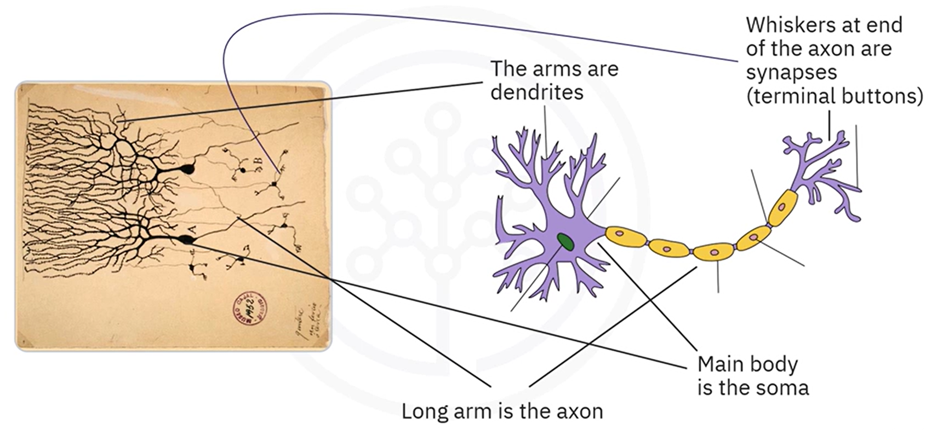

**🔄 Signal Propagation in the Brain:**

1. Dendrites receive electrical signals from the synapses of connected neurons.
2. Signals are transmitted to the **soma**, where they are aggregated and processed.
3. The result is passed through the **axon** to the **synapses**.
4. Synapses transmit the signal to thousands of other neurons, forming a dense, interconnected network.

This mechanism allows the brain to process sensory information, react to stimuli, and learn from experience through repeated activation of useful connections.

### 🔹Learning in Biological Neural Networks

Learning occurs by **reinforcing specific neural pathways**.

* The more a particular connection is used to produce a successful output, the stronger it becomes.
* This reinforcement makes the pathway more likely to activate again when similar input is received.

This concept of **adaptive strengthening of connections** forms the basis of learning in both biological and artificial neural systems.

### 🔹Artificial Neurons: Modeled Behavior

Artificial neurons are computational representations designed to mimic the functional structure of biological neurons.

* **Inputs** represent signals received from other neurons (analogous to dendrites).
* **Aggregation and activation** occur at the core of the neuron (analogous to the soma).
* **Output** is passed to subsequent neurons through weighted connections (analogous to the axon and synapses).

Like in the brain, artificial neurons are connected in **networks**, and the strength of each connection (represented by weights) can be adjusted during training to reinforce useful patterns.

| **Biological Component** | **Artificial Equivalent** |
| --- | --- |
| Dendrites | Input signals / features |
| Soma (with nucleus) | Weighted sum + activation |
| Axon | Output of the neuron |
| Synapse | Connection to other neurons |

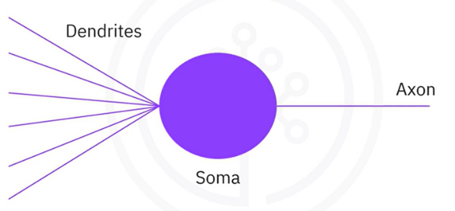

Both systems:

* Receive input signals
* Process and combine those inputs
* Generate outputs that influence subsequent components in the network

✅ Deep learning models are directly inspired by how neurons process and transmit information.

✅ Artificial neurons retain the key behavioral aspects of biological neurons, enabling them to learn patterns through weighted connections.

✅ The structure of neural networks is modeled on the interconnected nature of neurons in the brain, where outputs from one neuron become inputs for many others.

## 📌Artificial Neural Networks

### 🔹Foundations of Neural Networks

Artificial neural networks (ANNs) are inspired by the structure and function of biological neurons. The fundamental unit of an ANN is the **artificial neuron**, also referred to as a **perceptron**. Neural networks consist of many such neurons organized into layers that process and propagate information.

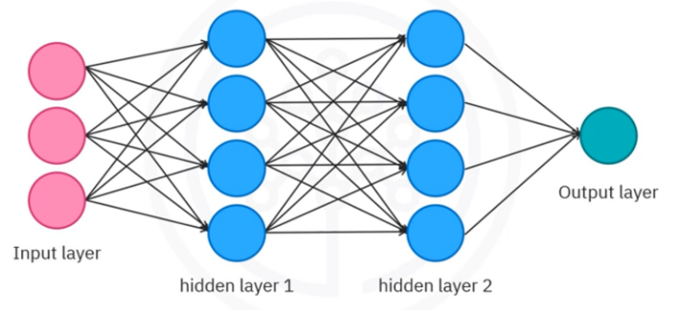The architecture typically includes:

* **Input Layer**: Receives external data and feeds it into the network.
* **Hidden Layers**: Intermediate layers that apply transformations to the data.
* **Output Layer**: Produces the final result or prediction of the network.

When working with neural networks, there are three essential concepts to understand:

1. **Forward Propagation** – how data flows through the network
2. **Backpropagation** – how the network learns from errors
3. **Activation Functions** – how non-linearity is introduced

This section focuses on **forward propagation**, which is the process by which input data moves through the layers of a neural network—from input to output—transforming at each layer. The flow of information is regulated by the **weights** assigned to each connection, which can be thought of as controlling the strength of each input.

The neurons receive input values (e.g., x1x_1x1​, x2x_2x2​), adjust them using their respective weights (e.g., w1w_1w1​, w2w_2w2​), and then process them through a mathematical function to produce an output. This structure mimics biological connections and enables a network of neurons to compute increasingly abstract representations.

### 🔹The Perceptron: Mathematical Formulation

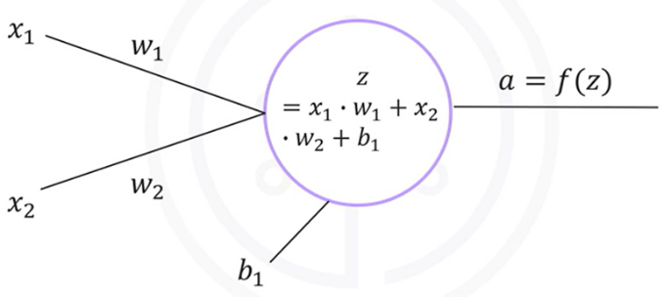Let:

* $x_{1}, x_{2},…, x_{n}$**​** be the input values
* $w_{1}, w_{2},…, w_{n}$**​** ​ be the weights associated with those inputs.
* **b** be the bias term.

An artificial neuron processes inputs using a simple mathematical operation.

The neuron computes a **linear combination** of inputs and weights, then adds the bias:

$$z=\sum_{i=1}^{n}{x_{i}w_{i}+b}$$

To introduce non-linearity and enable the network to model complex relationships, the neuron applies an **activation function $f$** to $z$:

$$a=f(z)$$

Here:

* $z$: weighted sum + bias
* $a$: output of the neuron
* $f$: activation function (e.g., sigmoid, ReLU)

This formulation allows the network to learn from data and adapt the weights and biases to minimize prediction error.

### 🔹Activation Functions and Their Role

A neural network without activation functions is essentially equivalent to a linear model. To overcome this limitation, activation functions introduce non-linearity, allowing the network to learn and approximate complex patterns and decision boundaries.

**🔸 Example: Sigmoid Activation**

The **sigmoid function** is a common choice in binary classification:

$$σ\left(z\right)=\frac{1}{1+e^{-z}}$$

It maps $z$ to $a$ value between 0 and 1:

* If $z$ is a large positive number, $σ\left(z\right)≈1$
* If $z$ is a large negative number, $σ\left(z\right)≈0$

Other activation functions (not covered yet but implied) include ReLU, tanh, and softmax.

ℹ️**Note:** **Without activation functions, a neural network collapses to a linear regression model and loses the capacity to solve non-linear problems**.

### 🔹Forward Propagation in Detail

**Forward propagation** is the process by which data moves through the neural network from the input layer to the output layer. Each neuron:

1. Receives inputs.
2. Computes a weighted sum.
3. Adds a bias.
4. Applies an activation function.
5. Passes the result to the next layer.

This happens layer by layer, allowing the network to transform the input data progressively into a meaningful output.

#### ⚙️Example: Single Neuron Forward Propagation

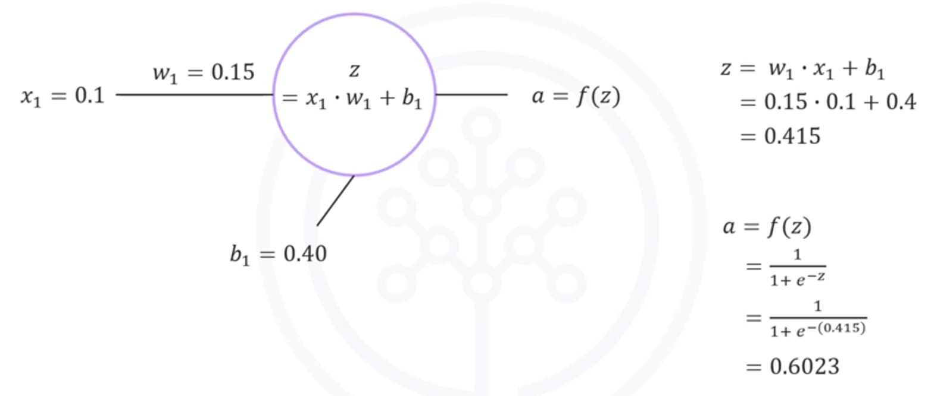

**This value (0.6023) is the output of the neuron.**

#### ⚙️Example: Two-Neuron Chain

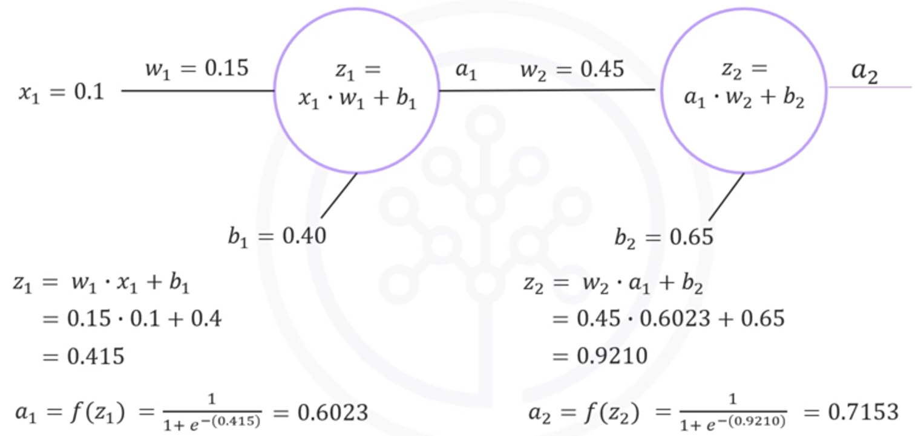

So, for an input of $x_{1}=0.1$, the network outputs a final prediction of approximately **0.7153**.

**🧠 Generalization:**

No matter how large or complex the network becomes, this step-by-step pattern—linear combination + activation—remains the same.

Neural networks rely on **layered computation**, and each layer transforms the input into a higher-level representation. This hierarchy enables the network to learn abstract concepts from raw data.

### ✅Takeaways

✅ Artificial neurons (perceptrons) compute a **weighted sum + bias**, followed by an **activation function**.

✅ Neural networks are made up of **layered perceptrons**, and each layer builds on the representation of the previous one.

✅ **Forward propagation** is the core mechanism that drives prediction in a neural network.

✅ Activation functions are essential to break linearity and enable deep learning models to capture complex relationships.

✅ With known weights and biases, it's possible to compute the output of any neural network given an input — regardless of its depth or width.

✅ The concepts of **backpropagation** and deeper insights into **activation functions** will further extend this foundation and are addressed in upcoming sections.

# Module 2

## Deep Learning Fundamentals

## 📌Gradient Descent

In neural networks, learning consists of **optimizing the weights and biases** of the model to reduce prediction error. This is achieved by minimizing a **cost function** (also known as a loss function), which quantifies the difference between the predicted output and the actual target values.

Before discussing how neural networks perform this optimization, it's essential to understand **gradient descent**—the foundational algorithm that drives the training process in deep learning.

### 🔹Understanding the Cost Function

Suppose we have a simple linear relationship between two variables:

$$z=w.x$$

To find the best possible value of the weight www that minimizes the prediction error between the actual values of $z$ and the predicted values $\hat{z}$, we define a **cost function**.

$$J(w)=\frac{1}{2n}\sum_{i=1}^{n}{{\left(z_{i}-w.x_{i}\right)}^{2}}$$

This function penalizes the squared differences between the predicted and actual values, and the $\frac{1}{n}$ ​ term ensures that the cost is independent of the dataset size.

* $n$: number of samples
* $z_{i}$ ​: actual target value
* $w.x_{i}$ ​: predicted value using current weight

For a perfectly linear case like $z=2x$, this cost function has a parabolic shape with a unique global minimum at $w=2$.

### 🔹What is Gradient Descent?

**Gradient descent** is an iterative optimization algorithm used to find the **minimum** of a function. In machine learning, it is used to minimize the cost function by adjusting model parameters.

**🧭 Basic Intuition:**

* Imagine standing on a curved surface representing the cost function.
* The **gradient** at any point tells you the direction of **steepest ascent**.
* To minimize the cost, move in the opposite direction: **steepest descent**.

The algorithm begins with an initial guess for the parameter $w$, denoted as $w_{0}$ ​, and gradually updates it in the direction that reduces the cost.

### 🔹Gradient Descent Formula

Given:

* $w_{0}$ ​: Initial weight
* $α$: Learning rate (controls step size)
* $\frac{dJ}{dw}$ ​: Gradient of the cost function with respect to $w$.

The weight update rule:

$$w_{t+1}=w_{t}-α.\frac{dJ(w_{t})}{dw}$$

Each iteration involves:

1. Computing the gradient (slope) at the current weight.
2. Scaling the gradient by the learning rate.
3. Subtracting this value from the current weight to move toward the minimum.

This process continues until convergence—i.e., until the gradient becomes close to zero or the cost stops decreasing significantly.

The **learning rate $α$** is a critical hyperparameter that affects the behavior of the algorithm.

Choosing an appropriate learning rate is essential for stable and efficient training. In practice, it’s often determined through experimentation or learning rate scheduling techniques.

Scenario:

* **Too Large () 🡪** Overshooting the minimum; possibly diverging or oscillating around it.
* **Too Small () 🡪** Very slow convergence; many iterations needed to reach the minimum.
* **Optimal Range 🡪** Balanced updates; smooth and efficient convergence.

### 🔹Behavior Around the Minimum

Gradient descent automatically adjusts its step size based on the steepness of the cost curve:

* **Far from the minimum**: Gradient is steep → large steps
* **Near the minimum**: Gradient flattens → smaller steps

This natural slowdown helps the algorithm fine-tune the parameters as it approaches the optimal value.

Additionally:

* If initialized **left of the minimum**, the gradient is **negative**, and the update moves to the right
* If initialized **right of the minimum**, the gradient is **positive**, and the update moves to the left

This symmetry ensures convergence to the optimal value from various starting points.

### 🔹Visualizing the Iterative Optimization

Let’s walk through a numerical example using synthetic data where $z=2x$:

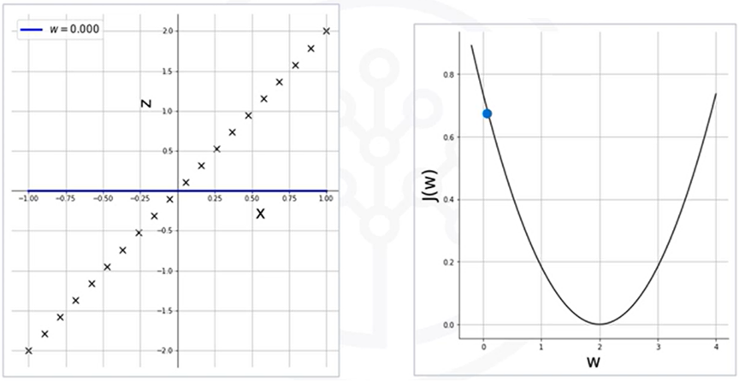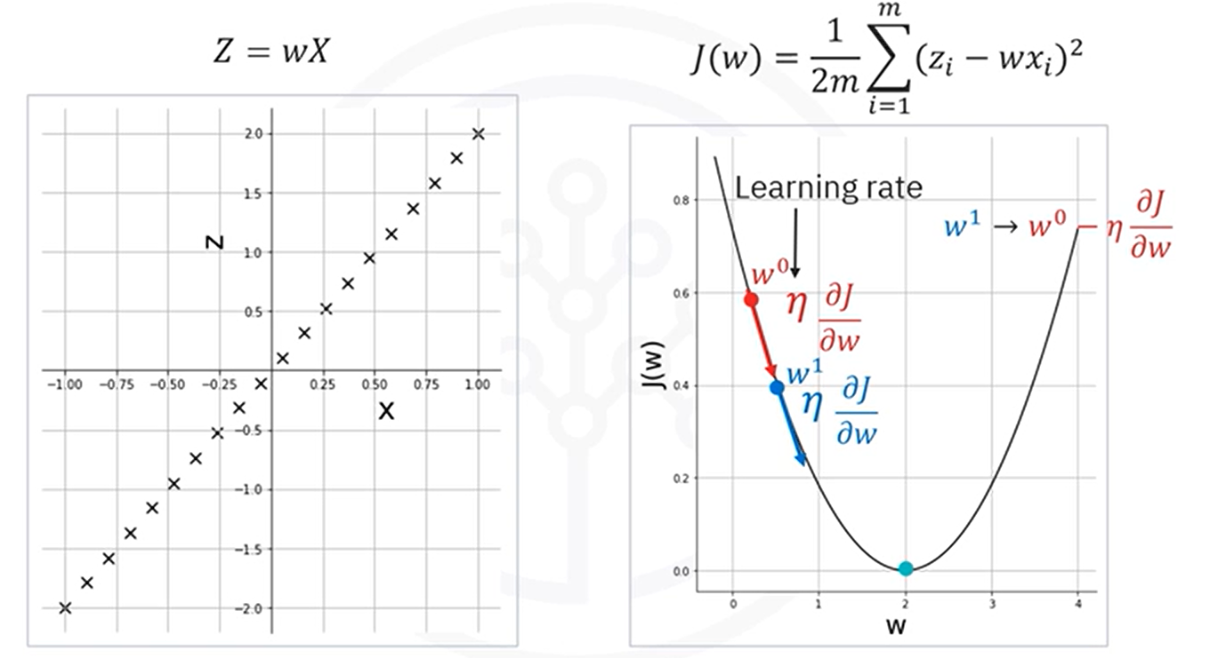

**Initialization:**

* Starts with 🡪 This results in predictions $\hat{z}=0$ (a flat line).
* This is a **poor fit**, so the **cost is high**.

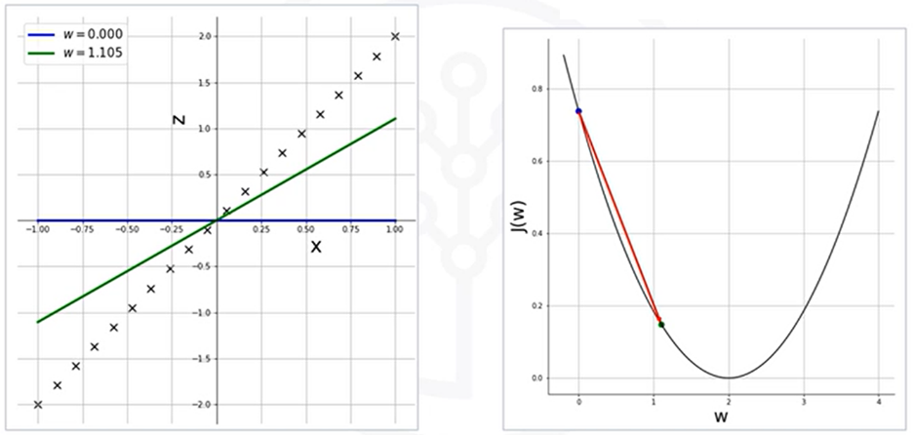**Iteration 1:**

* Compute gradient at $w_{0}$

​
* Update to $w_{1}$ ​ using the formula
* The weight jumps closer to 2, resulting in a lower cost and better line fit

**Iteration 2 and Beyond:**

* 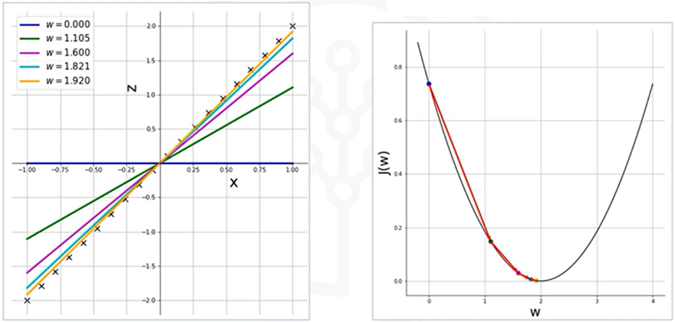The slope at the new point is less steep, so the update is smaller
* Each subsequent step brings the weight closer to the optimal value $w=2$
* The cost continues to drop, and the prediction line aligns more closely with the data

After four iterations, you can see how we're almost there at w equals 2, and the resulting line almost fits the scatter plot perfectly.

With each iteration, the weight is updated in a way that's proportional to the negative of the gradient of the function at the current point. Therefore, if you initialize the weight to a value that is to the right of the minimum, then the positive gradient will result in w moving to the left towards the minimum.

### ✅Takeaways

✅ The goal of training a neural network is to **minimize the cost function** by adjusting the weights and biases.

✅ **Gradient descent** is the core algorithm that performs this minimization through **iterative updates**.

✅ The size and direction of updates depend on the **gradient** and the **learning rate**.

✅ A **well-chosen learning rate** is crucial—too high can destabilize training, too low can make it inefficient.

✅ Although this example uses a single weight, the concept extends to **multivariate optimization** in deep networks where thousands or millions of parameters are adjusted simultaneously.

## 📌Backpropagation

The learning process in a neural network involves minimizing the **error** between the predicted output and the actual (ground truth) labels using a procedure known as **backpropagation**.

This process is central to **supervised learning**, where the dataset includes known input-output pairs, and the goal is to make the model output match the target values as closely as possible.

### 🔹What Is Backpropagation?

**Backpropagation** is the learning mechanism that allows a neural network to adjust its internal parameters — the **weights** and **biases** — to improve its predictions. It is applied during the training phase under **supervised learning**, where each input has a known, corresponding label (also called **ground truth**).

The purpose of backpropagation is to **minimize the error** between the network's predicted output and the actual target values by propagating that error backward through the network and using it to update each parameter in the model.

### 🔹The Role of Backpropagation in Training

Training begins when the output generated by the neural network does **not match the ground truth** for a given input. This mismatch indicates that the model has made an error, and this error becomes the basis for learning.

The process starts with:

1. Performing a **forward pass**: The input moves through the network to produce a predicted output.
2. **Computing the error**: The difference between the predicted output and the actual label is measured using a cost or loss function.
3. Using the **error signal** to perform backpropagation: This step determines how each weight and bias contributed to the error and adjusts them accordingly using gradient descent.

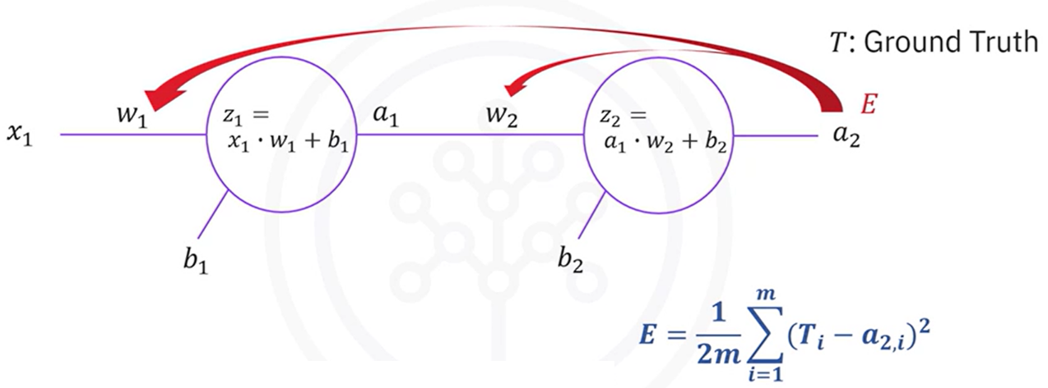

The backpropagation algorithm applies the **chain rule of calculus** to compute the **partial derivatives** of the error with respect to each parameter in the network. These derivatives (gradients) tell us how sensitive the error is to changes in each weight or bias.

Because weights and biases affect the error **indirectly** through several intermediate computations (activations, pre-activations, etc.), their gradients are **not directly observable**. Instead, backpropagation breaks the entire derivative into smaller, local derivatives that can be chained together.

For Example:

**Updating w2:**

To update w2 we use the error

$$w_{2}=w_{2}-α\frac{δE}{δw_{2}}$$

The cost E is **not directly a function of w2**, so, we compute:

Each term:

**Updating b2:**

It’s like w2, but the derivative is respective to b2.

**Updating w1:**

This requires deeper chaining because w1 **influences the error indirectly**:

$$w_{1}=w_{1}-α\frac{δE}{δw_{1}}$$

Since E is not directly a function of w1, we must use chain rule to obtain the derivative of E respect w1.

Each term:

**Updating b1:**

It’s like w1, but the derivative is respective to b1.

Thus, a longer chain of dependencies is built and applied to calculate the gradient.

Each of these local derivatives is **multiplied** together in the correct order to compute the total gradient with respect to each parameter.

For parameters **closer to the output layer**, the gradients involve fewer steps.

For parameters **closer to the input layer**, more intermediate computations are involved:

* Output error → output activation → output pre-activation → hidden activation → hidden pre-activation → weight

The more distant a parameter is from the output; the more layers must be traversed backward to determine how it influenced the final output. Backpropagation systematically handles this traversal using the chain rule, regardless of how many layers are involved.

#### ⚙️ Parameter Updates

Once the gradient of the error is computed for a particular parameter (e.g., a weight or bias), it is updated using **gradient descent**:

* The parameter is moved **in the opposite direction of the gradient**, which is the direction that reduces the error.
* The **learning rate** controls how large each step is.
* This is done **simultaneously for all parameters** in the network.

#### 🔄 Repeating the Process

Backpropagation is performed **repeatedly**, across:

* Many **training samples**
* Multiple **epochs** (full passes through the dataset)

At each iteration:

1. A forward pass is computed for the current input.
2. The error is calculated by comparing the prediction with the true label.
3. Backpropagation is used to distribute this error backward.
4. Weights and biases are updated.
5. The process repeats with new inputs and updated parameters.

The goal is to continue this loop until:

* A predefined number of iterations (epochs) has been completed.
* The error becomes sufficiently small — below a defined **threshold**.

### ✅ Takeaways

✅ **Backpropagation** is the algorithm that allows a neural network to learn from its mistakes.

✅ It works by using the **chain rule** to determine how each weight and bias influenced the final prediction error.

✅ These gradients are used to **update the parameters** using gradient descent.

✅ The process is repeated over many iterations, leading the network to converge toward a solution that minimizes the error.

## 📌Vanishing Gradient

### 🔹The Vanishing Gradient Problem: Overview

One of the most significant challenges in training deep neural networks—particularly before the rise of modern architectures—is the **vanishing gradient problem**. This issue, tied closely to certain activation functions such as the **sigmoid**, can severely slow down or even halt the learning process, especially in networks with many layers.

This problem is one of the reasons neural networks did not gain widespread success earlier, despite their theoretical potential.

In deep networks, the training process uses **backpropagation** to compute how the loss function responds to changes in each weight. This requires calculating **gradients** (partial derivatives) that are propagated backward through the network.

The problem becomes apparent when the network:

* Uses the **sigmoid activation function**
* Has **multiple layers**, especially more than two

The **sigmoid function**:

$$σ\left(z\right)=\frac{1}{1+e^{-z}}$$

maps all inputs to the range (0, 1). As a result:

* Its output values are **bounded**, never becoming very large or very small
* The **derivative** of the sigmoid is also between 0 and 0.25
* Gradients calculated during backpropagation will also be **less than 1**

#### ⚠️ Why Sigmoid is Problematic

The **sigmoid function**, and similar bounded activation functions (like tanh), are especially prone to this issue:

* Their output is **bounded** between 0 and 1
* Their gradients are **less than or equal to 0.25**
* Repeated application in deep networks leads to exponentially vanishing gradients

While the sigmoid was historically popular due to its smoothness and probabilistic output interpretation, its use in deep networks is now discouraged for this reason.

### 🔹How Gradients Disappear

During backpropagation, gradients are computed using the **chain rule**, meaning the gradient at a given layer depends on the product of all gradients in the layers that follow it.

When these gradients are each **less than 1**, repeated multiplication causes them to **shrink exponentially** as they propagate backward through the network. This means:

* Gradients in the **last layers** (closer to the output) may still have meaningful values
* But gradients in the **early layers** (closer to the input) become **extremely small**
* This leads to **very slow updates** for those weights during training

As a result:

* Early-layer neurons learn **very slowly**
* Training becomes **inefficient or unstable**
* Final prediction performance suffers due to **undertrained lower layers**

#### ⚠️ Consequences in Training

**🔸 Learning Imbalance**

* Later layers continue to update and learn features
* Earlier layers remain nearly static due to minuscule gradients
* The model may overfit shallow patterns while ignoring deeper structure

**🔸 Slower Convergence**

* More iterations (epochs) are needed to reach reasonable performance
* Optimization becomes inefficient, especially in large networks

**🔸 Compromised Accuracy**

* Incomplete learning in earlier layers leads to suboptimal representations
* This directly impacts the model’s ability to generalize on unseen data

### ✅Takeaways

✅ The **vanishing gradient problem** occurs when gradients become very small as they are propagated backward through a deep neural network.

✅ This problem is primarily caused by **activation functions like sigmoid**, whose derivatives are always less than 1.

✅ As a result, **earlier layers learn very slowly**, making training inefficient and hurting model accuracy.

✅ To avoid this issue, modern neural networks typically use **activation functions like ReLU**, which do not suffer from vanishing gradients in the same way.

## 📌Activation Functions

### 🔹Role of Activation Functions in Neural Networks

**Activation functions** are essential components in neural networks. They introduce **non-linearity** into the model, enabling it to learn complex patterns, capture interactions between inputs, and represent highly flexible decision boundaries. Without activation functions, neural networks would reduce to a series of linear operations and would not be able to learn or approximate non-linear mappings.

In addition to their functional role in transforming inputs, activation functions influence **training behavior**, **gradient flow**, and **computational efficiency**. The choice of activation function can significantly affect model convergence, depth, and generalization.

### 🔹Limitations of the Sigmoid Function

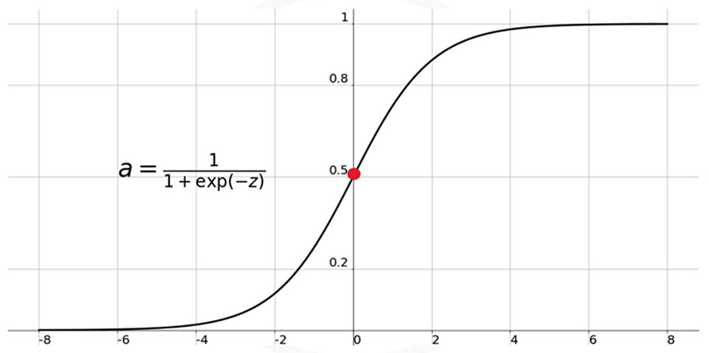The **Sigmoid (logistic)** function was historically used in neural networks due to its smooth gradient and interpretable output.

It maps all input values to a range between **0 and 1**, with:

$σ\left(0\right)=0.5$

$σ\left(z\right)→1 as z→+∞$

$σ\left(z\right)→0 as z→-∞$

Despite its early popularity, the Sigmoid function has significant drawbacks:

**🔸 Vanishing Gradient Issue**

* The function **saturates** for large positive or negative inputs.
* In these saturation zones (e.g., beyond ±3), the derivative becomes **extremely small**, often near zero.
* During backpropagation, gradients get multiplied through the layers. When these values are small, the **gradients diminish** rapidly as they move backward through the network.
* This leads to the **vanishing gradient problem**, where **earlier layers stop learning** effectively.

**🔸 Lack of Symmetry**

* Sigmoid outputs are always **positive**.
* This causes all subsequent layers to receive inputs of the same sign, potentially **biasing the network’s learning** and slowing convergence.

### 🔹Commonly Used Activation Functions

#### 🔧 Sigmoid Function

**ℹ️ Range:** (0,1)

**💡 Advantages:**

* + Historically popular due to smooth, bounded output.

**⚠️ Limitations:**

* + **Vanishing gradient problem**: The function flattens out for large inputs, producing gradients close to zero. This slows or stops learning in earlier layers.
  + **Non-zero-centered output:** All values are positive, which can bias neuron activations and hinder learning.
  + **Poor performance** in deep networks.

**✅ Usage:**

* + Rarely used in hidden layers today due to these issues.

#### 🔧 Hyperbolic Tangent (Tanh) Function

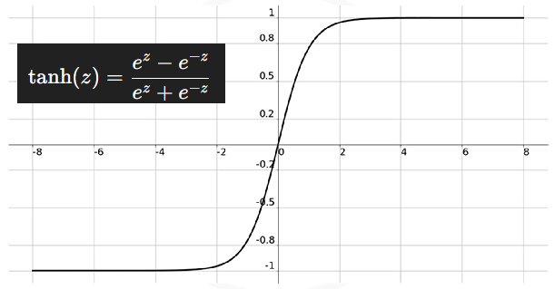**ℹ️ Range:** (-1,1)

**💡 Advantages:**

* + **Symmetric about the origin,** addressing the imbalance issue of sigmoid.
  + Slightly better than sigmoid in terms of convergence.

**⚠️ Limitations:**

* + Still suffers from the **vanishing gradient problem**, especially in deep networks.
  + Poor scalability in deep learning when used in hidden layers.

**✅ Usage:**

* + Occasionally used in shallow networks, but largely replaced by ReLU in modern practice.

#### 🔧 ReLU Function

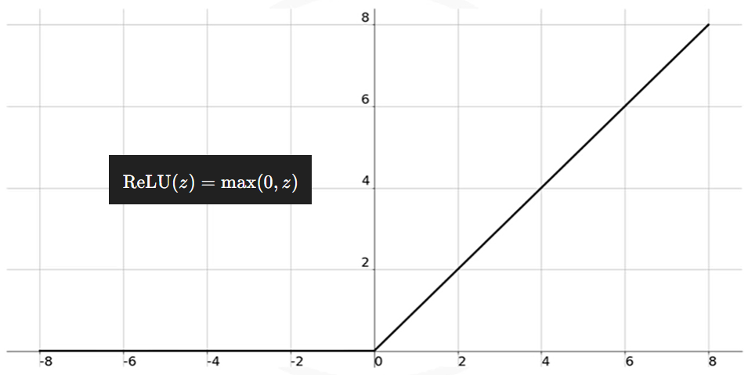**ℹ️ Range:** {0,∞)

**💡 Advantages:**

* + **Avoids vanishing gradients** for positive inputs.
  + Enables **sparse activations**, as only neurons with positive input values activate.
  + **Computationally efficient** and simple to implement.
  + Enabled deep learning advancements due to its robustness.

**⚠️ Limitations:**

* + **Inactive neurons**: If inputs are negative, the neuron is not activated (output is 0). This can lead to some neurons never updating (known as the **"dying ReLU"** problem).

**✅ Usage:**

* + Default choice for hidden layers in modern deep networks.
  + Not used in the output layer.

#### 🔧 Softmax Function

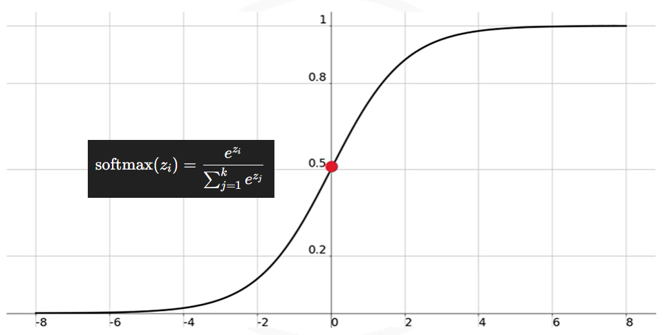**ℹ️ Range:** (0, 1), and all outputs sum to 1.

**💡 Advantages:**

* + Converts raw output scores into **probability distributions** over classes.
  + Helps **classify inputs in multi-class** problems.

**⚠️ Limitations:**

* + Computationally heavier than ReLU or sigmoid.
  + Not suitable for hidden layers; limited to output layer in classification.

**✅ Usage:**

* + Used **exclusively in the output layer** of classifiers where multi-class probability prediction is needed.

#### 🔧 Overview of Activation Function Types

| **Activation Function** | **Output Range** | **Common Usage** | **Notes** |
| --- | --- | --- | --- |
| Binary Step | {0, 1} | Simple thresholding | Not used in practice due to lack of gradient |
| Linear (Identity) | −∞,∞ | Regression models | No non-linearity; unsuitable for deep learning |
| Sigmoid | (0, 1) | Historically in hidden layers | Leads to vanishing gradients and slow convergence |
| Tanh | (-1, 1) | Hidden layers (less common now) | Symmetric over the origin; still suffers from vanishing gradients |
| ReLU | [0, ∞) | Hidden layers (standard today) | Sparse activation; efficient; avoids vanishing gradients |
| Leaky ReLU | (-∞, ∞) | Hidden layers | Variant of ReLU; avoids dead neurons |
| Softmax | (0, 1), sums to 1 | Output layer of classifiers | Outputs probabilities for multi-class problems |

### 🔹Practical Guidelines for Activation Function Choice

**🧠 Avoid** using **sigmoid** and **tanh** in hidden layers of deep networks due to vanishing gradient problems.

**🧠** Use **ReLU** as the **default** activation function in hidden layers.

**🧠** Use **softmax** in the **output layer** of multi-class classifiers.

**🧠** If ReLU yields suboptimal performance, consider variants like **Leaky ReLU** or explore other activation strategies (e.g., Swish, GELU — not covered here).

### ✅Takeaways

✅ Activation functions are central to a network’s ability to **learn non-linear patterns**.

✅ The **choice of activation function** affects training speed, gradient stability, and model accuracy.

✅ The **sigmoid and tanh** functions are mostly avoided in deep architectures due to their tendency to produce **vanishing gradients**.

✅ **ReLU** has become the dominant choice for hidden layers, thanks to its simplicity and effectiveness.

✅ **Softmax** is used in the output layer when the model must produce **probabilistic class predictions**.

# Module 3

## Keras and Deep Learning Libraries

## 📌Deep Learning Libraries

Before building deep learning models, it is important to understand the **tools and libraries** that support their development. Over the past decade, several deep learning frameworks have emerged, each with its own strengths and design philosophy. This section introduces the **three most commonly used libraries** in practice and in this specialization: **TensorFlow, PyTorch, and Keras**.

### 🔹Overview of Major Libraries

🛠 **TensorFlow**

1. **Developer:** Google
2. **Released:** 2015
3. **Usage:**
   * Most widely used deep learning library in both **research and production**.
   * Backed by a **large developer community**.
   * Actively maintained and improved with regular updates and enhancements.
4. **Strengths:**
   * Scalable for large models and systems.
   * Supports **deployment at scale**, including on mobile and edge devices.
   * Integrated with tools for production workflows (e.g., TensorFlow Serving, TensorFlow Lite).
5. **Limitations:**
   * Known for having a **steep learning curve**, especially for beginners.
   * Requires explicit graph construction and management of session contexts in its low-level APIs.

🛠 **PyTorch**

1. **Developer:** Meta(Facebook)
2. **Released:** 2016
3. **Origin:** Based on **Torch** framework written in Lua.
4. **Usage:**

* Rapidly adopted in the **academic research community**.
* Known for its dynamic computational graph and **Pythonic design**.
* Often preferred when working with **custom architectures** and experimental workflows.

1. **Strengths:**
   * **Intuitive and flexible** interface that feels native to Python users.
   * Excellent GPU support.
   * Increasing adoption in production through frameworks like TorchServe and ONNX.
2. **Limitations:**
   * Like TensorFlow, it also has a **learning curve**, particularly for complete beginners.
   * Lower-level model building can require more manual control compared to high-level APIs.

🛠 **Keras**

1. **Type:** High-level API
2. **Integration:** Runs on top of **TensorFlow** as backend.
3. **Usage:**

* Designed for **ease of use**, **clean syntax**, and **rapid prototyping**.
* Allows building **complex deep learning networks** with just a few lines of code.

1. **Strengths:**
   * Great for **beginners**, teaching, and small- to medium-scale projects.
   * Abstracts away many low-level details, allowing users to focus on the model structure and data.
   * Actively supported by Google.
2. **Limitations:**
   * Less fine-grained control compared to TensorFlow and PyTorch.
   * Advanced users may prefer to work directly with lower-level frameworks when custom behavior is required.

### 🔹Summary of Comparison

| **Feature** | **TensorFlow** | **PyTorch** | **Keras** |
| --- | --- | --- | --- |
| Developer | Google | Meta (Facebook) | Initially François Chollet (Google) |
| Released | 2015 | 2016 | High-level API |
| Popularity | High in production and research | Increasing in research and industry | Very popular among beginners |
| Learning Curve | Steep | Moderate to steep | Easy |
| Ideal Use Case | Large-scale systems | Research, prototyping | Fast prototyping, learning |
| Control/Customization | High | High | Moderate |
| Backend Dependency | Native | Native | Runs on TensorFlow |

### ✅Takeaways

✅ The most widely used deep learning libraries today are **TensorFlow**, **PyTorch**, and **Keras**.

✅ **TensorFlow** is widely used in production, has robust community support, and is backed by Google.

✅ **PyTorch** is preferred in **academic research and custom model experimentation**, offering a flexible and Pythonic workflow.

✅ **Keras** is a high-level, beginner-friendly API that **simplifies deep learning development**, running on top of TensorFlow.

✅ Beginners are encouraged to start with **Keras** for its ease of use, while advanced users may leverage **PyTorch or TensorFlow** for fine-grained control.

## 📌Regression Models with Keras

This section introduces how to build and train a **regression model** using the **Keras** library. The goal is to predict a continuous value based on a dataset.

Keras allows you to construct and train deep learning models with **minimal code** and is ideal for quickly prototyping regression tasks using dense, feedforward neural networks.

### 🔹Building the Network Architecture

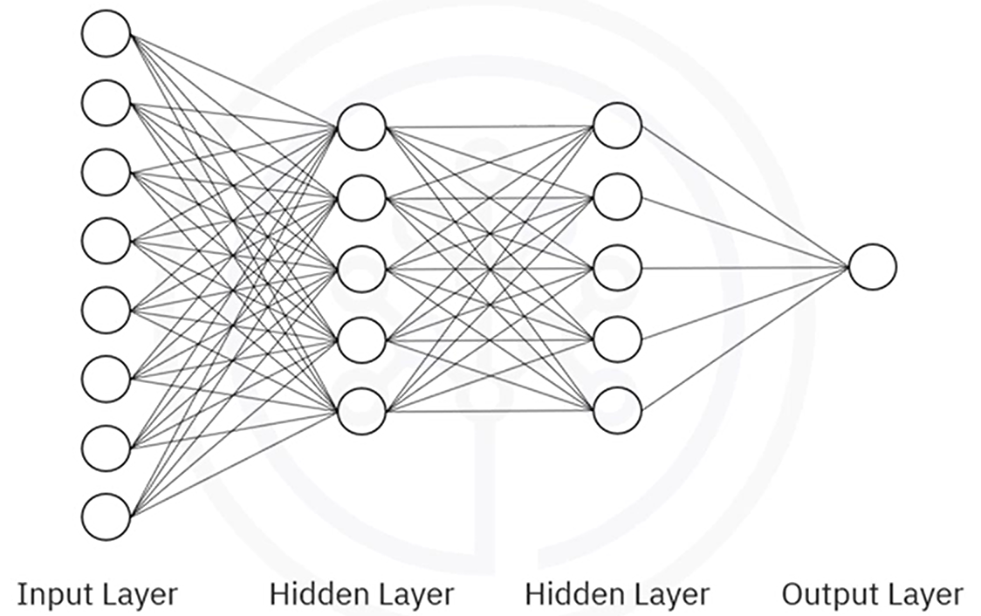

The model will consist of:

* **Input layer**: receives features.
* **Hidden layers**: apply transformations to extract patterns.
* **Output layer**: outputs a single continuous value.

✅ In hidden layers, it is standard practice to use **ReLU activation functions**.

✅ The output layer typically has **no activation function**, since it’s predicting a continuous value.

This type of network is called a **dense (fully connected) network**, where each neuron in one layer is connected to every neuron in the next.

While deeper or wider networks (e.g., with 50–100 neurons per layer) are often used in practice, smaller networks can also illustrate core concepts.

### 🔹Using Keras to Define the Model

Keras provides two ways to define models:

1. **Sequential API**: Used when layers are stacked one after the other (most common).
2. **Functional API**: Used for more advanced or non-linear architectures.

In most regression use cases; the **Sequential model** is appropriate.

**Step-by-step:**

1. **Import required modules:**

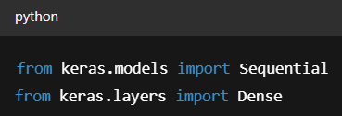

1. **Initialize the model:**

Use the Sequential API to stack layers.

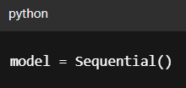

1. **Add Layers:**

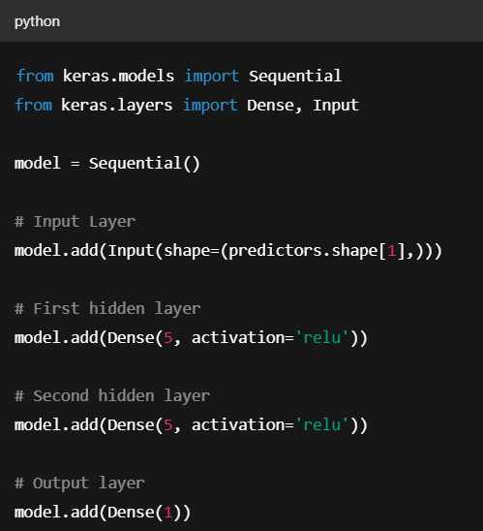

* + The **first layer** specifies the number of input features via input_shape parameter.
  + Each **hidden layer** uses **ReLU** to introduce non-linearity and improve learning.
  + The **final output layer** has one neuron with no activation (for raw value output).

1. **Compiling the Model:**

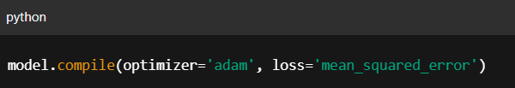

* + The **Adam optimizer** is commonly used in deep learning for its adaptive learning rate and efficiency , you don’t need to manually set a learning rate.
  + **Mean Squared Error (MSE)** is the standard loss function for regression as it penalizes large errors more than small ones.

1. **Training and Predicting:**

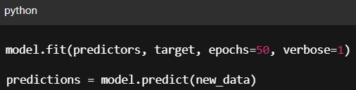

**All Together:**

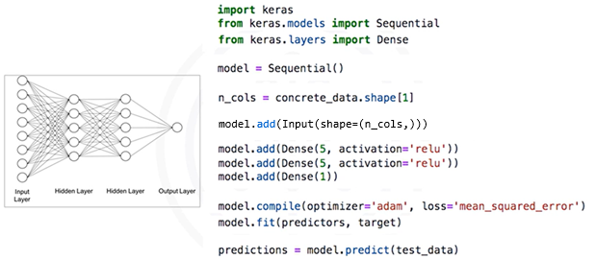

### ✅Takeaways

✅ Keras simplifies the process of building and training regression models using a **layered API** and sensible defaults.

✅ Input data must be separated into **predictors** and a **target**, with proper formatting for compatibility with neural network inputs.

✅ Use **Dense layers** for fully connected architectures, **ReLU** activations in hidden layers, and **no activation** in the output layer for continuous predictions.

✅ Compile the model with the **Adam optimizer** and **mean squared error loss** to effectively train on regression problems.

✅ The entire workflow—from data preparation to model training and prediction—can be implemented clearly and efficiently, allowing for fast prototyping and model deployment.

## 📌Classification Models with Keras

Classification models are built in Keras much like regression models: using the **Sequential API**, stacking Dense layers, and compiling with an optimizer and loss function.

However, there are **key differences** in how the data is prepared, how the output layer is configured, and what loss function and metrics are used.

**Step-by-step:**

1. **Preparing data:**

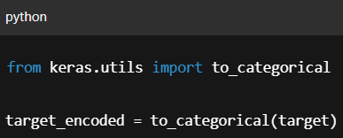

* + Just like in regression, we begin by splitting the dataset into **predictors** and **target**, but for classification, the target column contains **class labels**, which must be **one-hot encoded** before training.
  + Each row of the output represents a class with a 1 at the correct index and 0s elsewhere, If there are 4 classes, each target row becomes a vector like [0, 0, 1, 0].
  + This transformation is required to match the **output layer’s softmax structure** and for the loss function to compute properly.

1. **Network Architecture:**

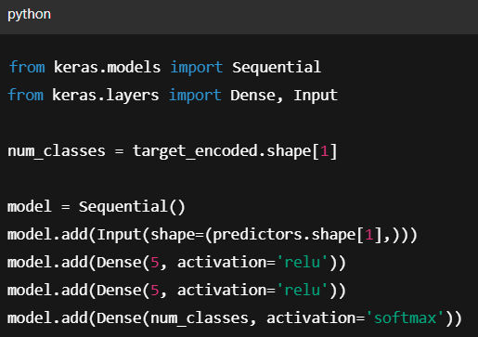

* 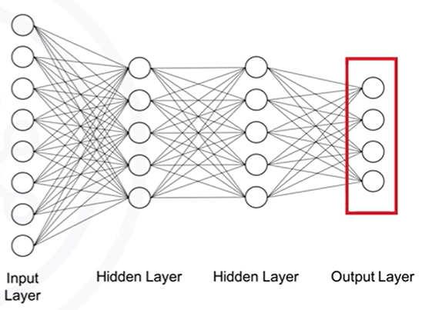The core network structure (input → hidden layers → output) remains the same as in regression, but there are **two important architectural differences**:

1. **The output layer must have as many neurons as there are classes.**
2. **The activation function of the output layer must be softmax.**

This allows the model to produce a **probability distribution** over the possible classes.

1. **Compiling the Model:**

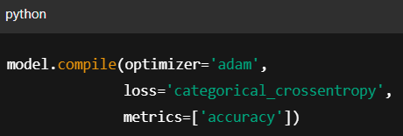

* + For classification, we switch the loss function to be ‘**Categorical crossentropy**’, this function is appropriate when the targets are one-hot encoded and the model outputs class probabilities.

1. **Compiling the Model:**



* + Just like with regression, each epoch passes the full dataset through the network, updates weights via backpropagation, and improves the model’s ability to predict the correct class.
  + Once the model is trained, we can make predictions using ***.predict()*.** This returns **class probabilities**, for example, if there are 4 classes, a prediction might look like

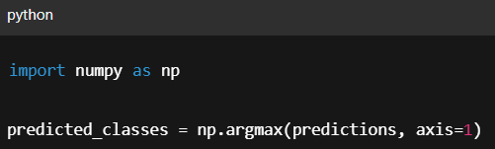-> **[0.01, 0.92, 0.04, 0.03]**

To get the predicted class label:

### ✅Takeaways

✅ The overall structure for classification and regression models in Keras is nearly identical, but classification requires:

* Transforming categorical targets using **to_categorical()**.
* Using a **softmax output layer**.
* Setting **categorical crossentropy** as the loss function.
* Evaluating using **accuracy** rather than a numerical error metric.

✅ Keras handles the internals of class probability calculation and training, so most of the additional steps are related to **data preparation and model configuration.**

# Module 4

## Deep Learning Models

## 📌Shallow vs Deep Neural Networks

### 🔹Differences Between Shallow and Deep Networks

Although there is no strict cutoff, the following is a commonly accepted rule of thumb:

* A **shallow neural network** has **one or two hidden layers**.
* A **deep neural network** has **three or more hidden layers**, typically with a **large number of neurons per layer**.

The increase in depth allows deep networks to model much more **abstract**, **hierarchical**, and **non-linear** representations of the input data.

| **Feature** | **Shallow Neural Networks** | **Deep Neural Networks** |
| --- | --- | --- |
| Depth | 1–2 hidden layers | 3 or more hidden layers |
| Input | Typically vectorized features | Capable of handling raw data (images, text, etc.) |
| Feature Engineering | Often requires manual feature extraction | Automatically extracts features |
| Representation Power | Limited | High (can learn hierarchical representations) |
| Use Cases | Simple, structured data | Complex data like images, audio, NLP, etc. |

Shallow networks are easier to understand and train, which makes them useful for **conceptual learning**, **prototyping**, and **simple tasks**.

Deep networks, on the other hand, are preferred when dealing with **complex input data** and problems that require **high abstraction**.

### 🔹Why Deep Learning Took Off

Although neural networks have existed for decades, the explosive growth and adoption of **deep learning** in recent years can be attributed to **three major breakthroughs**:

1. **Advancements in the Field:**

The development of **better activation functions**, especially **ReLU (Rectified Linear Unit)**, helped address one of the most critical limitations in deep learning: the **vanishing gradient problem**. This allowed deeper networks to train more effectively and enabled the creation of models with dozens or even hundreds of layers.

✅ ReLU maintains stronger gradients during backpropagation, which makes deep networks trainable at scale.

1. **Availability of Large Datasets**

Deep neural networks have an incredible capacity to **memorize and model large volumes of data**. However, this ability can lead to overfitting if the data is limited. The widespread availability of **large, labeled datasets** has unlocked the full potential of deep architectures.

✅ Unlike traditional machine learning algorithms, deep networks continue to improve with more data.

1. **Computational Power (GPUs)**

Training deep networks is computationally intensive. The rise of **powerful GPUs** (and later, TPUs and distributed computing) has made it feasible to:

* Train deep models on massive datasets.
* Perform experiments rapidly.
* Deploy models to production with manageable costs.

✅ What once took days or weeks can now be trained in hours using modern hardware.

### ✅Takeaways

✅ **Shallow neural networks** are defined by **1–2 hidden layers**, and typically require **vectorized inputs** and **manual feature extraction**.

✅ **Deep neural networks** consist of **multiple hidden layers**, and are capable of **automatically extracting features** from **raw input data** such as images and text.

✅ The modern success of deep learning is attributed to:

* **Better training techniques and architectures** (e.g., ReLU)
* **Widespread access to large datasets**
* **Powerful hardware that accelerates training**

## 📌Dropout and Batch Normalization

Two important techniques often used to improve the performance of neural networks: **Dropout Layers** and **Batch Normalization**.

### 🔹Dropout Layers

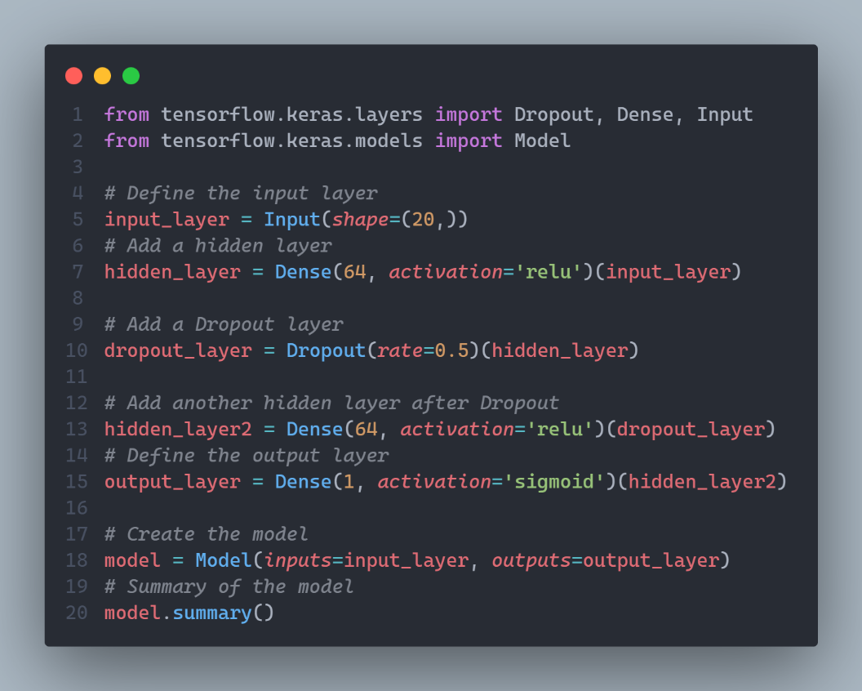Dropout is a regularization technique that helps prevent overfitting in neural networks. During training, Dropout randomly sets a fraction of input units to zero at each update cycle. This prevents the model from becoming overly reliant on any specific neurons, which encourages the network to learn more robust features that generalize better to unseen data.

**Key points:**

* Dropout is **only applied during training**, not during inference.
* The dropout rate is a hyperparameter that determines the fraction of neurons to drop.

### 🔹Batch Normalization

Batch Normalization is a technique used to improve the training stability and speed of neural networks. It normalizes the output of a previous layer by re-centering and re-scaling the data, which helps in stabilizing the learning process. By reducing the internal covariate shift (the changes in the distribution of layer inputs), batch normalization allows the model to use higher learning rates, which often speeds up convergence.

**Key Points:**

* Batch normalization works by **normalizing the inputs to each layer** to have a mean of zero and a variance of one.
* It is **applied during both training and inference**, although its behavior varies slightly between the two phases.
* Batch normalization layers also introduce two learnable parameters that allow the model to scale and - shift the normalized output, which helps in restoring the model's representational power.

## 📌Convolutional Neural Networks

**Convolutional Neural Networks (CNNs)** are a specialized type of deep learning architecture designed specifically for handling **image data** and other data with a grid-like structure (e.g., audio spectrograms).

Although CNNs are composed of neurons, weights, biases, and activation functions like standard dense neural networks, their design incorporates unique **architectural assumptions** that allow them to learn from raw image data more efficiently and with fewer parameters.

### 🔹Key Characteristics of CNNs

CNNs make the **explicit assumption** that inputs are **images**, and they process them using filters that take advantage of the **spatial structure** of the data.

Input shapes:

* Grayscale images: n x m x 1
* Color images: n x m x 3 (where 3 channels represent RGB)

CNNs are particularly powerful for:

* Image classification
* Object detection
* Image segmentation
* Face recognition
* Medical imaging analysis

### 🔹CNN Architecture Breakdown

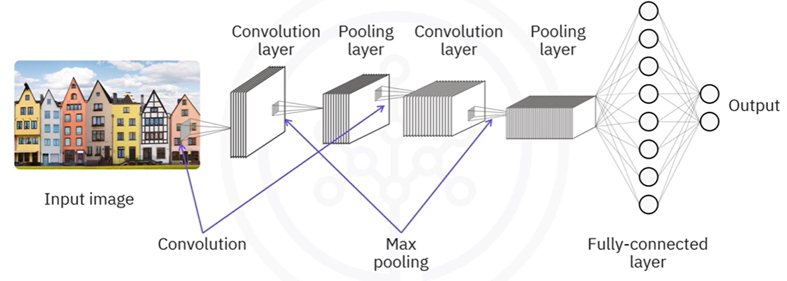

A typical **Convolutional Neural Network (CNN)** is composed of several key building blocks organized in a specific order to progressively extract spatial features from input images and make accurate predictions.

CNNs differ from the fully connected networks introduced earlier in that they assume **images as input**, maintaining their spatial structure. Instead of flattening the data up front, CNNs process **3D input tensors** using specialized layers that are better suited for handling **pixel-level patterns**.

1. **Input Layer:**

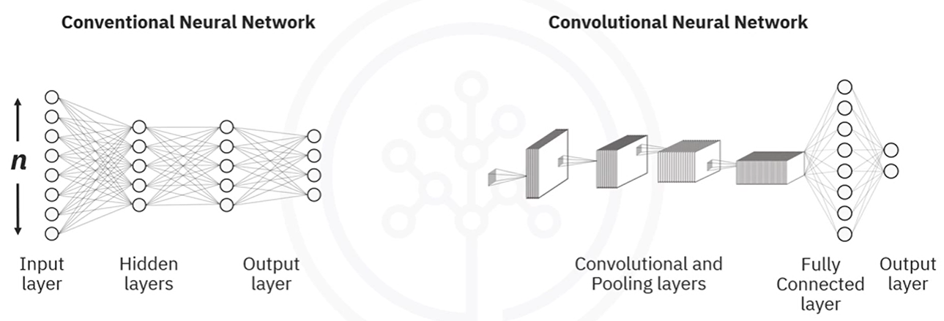

Unlike shallow networks that accept a **1D vector**, CNNs accept **3D inputs**:

* For grayscale images: height × width × 1
* For color images: height × width × 3 (RGB channels)

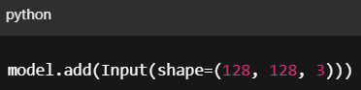For example, a 128×128 RGB image would have an input shape of (128, 128, 3).

This structure allows the model to **preserve spatial relationships** between pixels — crucial for tasks like object detection and image classification.

1. **Convolutional Layer:**

This is the **core feature-extracting layer** in a CNN. It applies a set of **filters** (also called kernels) that scan across the image in small patches.

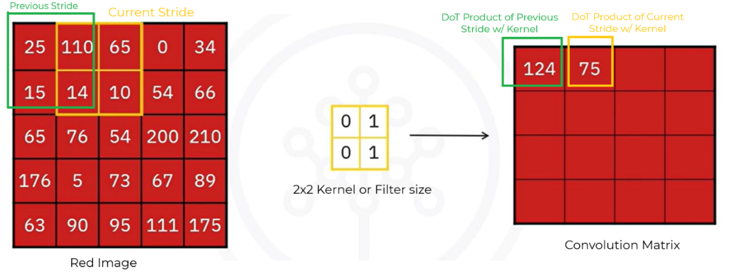

In the convolutional layer, we basically define filters and we compute the convolution between the defined filters and each of the three images (RGB).

This is the **core feature-extracting layer** in a CNN. It applies a set of **filters** (also called kernels) that scan across the image in small patches.

This structure allows the model to **preserve spatial relationships** between pixels — crucial for tasks like object detection and image classification.

Each filter performs a **dot product** between its values and a local patch of the image and stores the result in a new **feature map**.

* Typical filter sizes: 2×2, 3×3, 5×5
* Stride: how far the filter moves per step (usually 1)
* Depth: number of filters determines number of feature maps

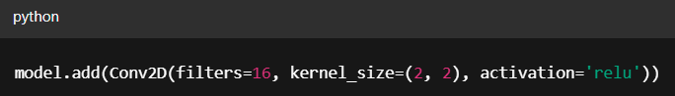

**⚠️ Why not flatten the input image into an [ (n x m) x 1 ] vector and pass it into a dense network?**

* Flattening large images would result in **huge parameter counts**, increasing computational cost and overfitting risk.
* Convolution drastically reduces parameters by reusing filters across regions of the image, while maintaining spatial locality.

ℹ️ **ReLU Activation (within Conv2D)**

Each convolutional layer is followed by a **ReLU (Rectified Linear Unit)** activation function. This layer:

* Keeps only **positive values**
* Sets all **negative values to zero**
* Adds **non-linearity** to the model

ReLU ensures the model can learn complex, non-linear representations efficiently, and avoids the vanishing gradient issues of older activations (like sigmoid).

1. **Pooling Layer (MaxPooling2D / AveragePooling2D):**

The pooling layer **reduces the spatial dimensions** of the feature maps. It helps the network become more invariant to small shifts or distortions in the input image.

There are two common types:

* **Max Pooling**: keeps the largest value in each region.

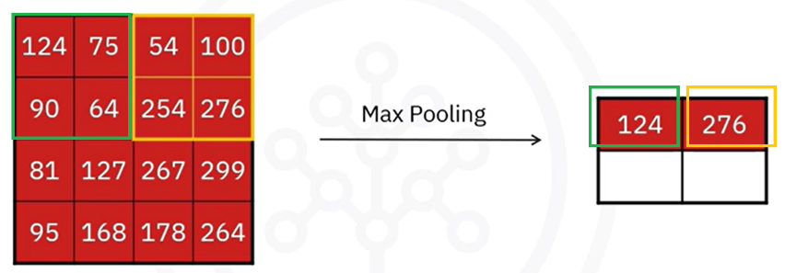

* **Average Pooling**: computes the average of each region

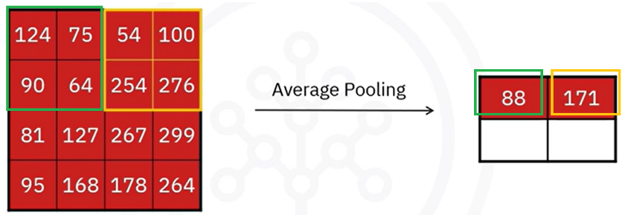

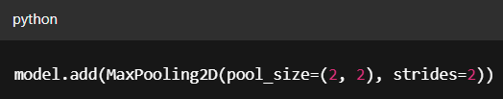Example: with a 2×2 filter and a stride of 2, the pooling operation slides over the image in blocks, shrinking the dimensions while retaining key features.

✅ Pooling offers:

* **Dimensionality reduction**
* **Noise suppression**
* **Spatial invariance**

#### 🔁 Repeat: Additional Convolution + Pooling Blocks

Deeper CNNs stack multiple convolution and pooling layers. Typically:

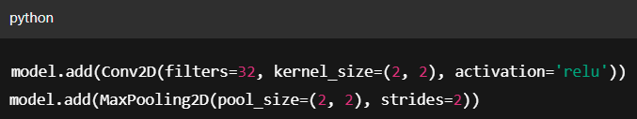

* Deeper layers use **more filters** to capture more abstract and complex features.
* Each additional block allows the network to **build a hierarchy of features**, from edges and textures to shapes and object parts.

1. **Flatten Layer:**

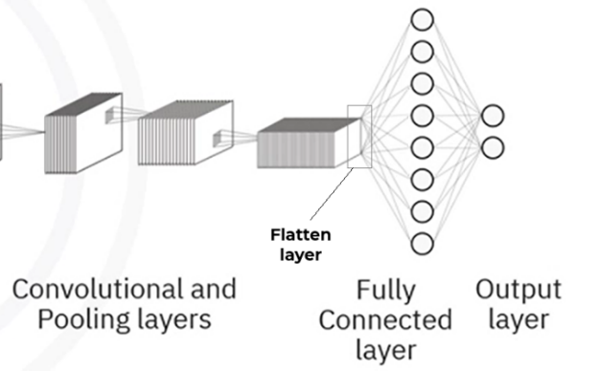

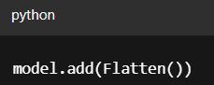Before passing data to a fully connected layer, the 3D output of the final convolution/pooling layer is **flattened** into a 1D vector.

⚠️ This conversion is **necessary** because **dense layers expect flat inputs**. The flattened vector represents all the high-level features extracted from the image.

1. **Fully-Connected Layer:**

These layers operate like the traditional dense layers introduced earlier:

* Each node in one layer is connected to **every node** in the next.
* Often used to **combine features** and make the final prediction.

1. **Fully-Connected Layer:**

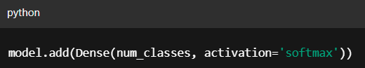The final output layer produces predictions. Its size depends on the number of classes:

* Use **softmax activation** to convert output values into probabilities that sum to 1.
* Each neuron corresponds to one possible class.

### 🔹Complete Flow of CNN Layers

| **Layer** | **Purpose** |
| --- | --- |
| Input | Accepts image in 3D shape (e.g., 128×128×3) |
| Convolution (Conv2D) | Detects features by applying filters |
| ReLU | Adds non-linearity, filters out negative values |
| Pooling | Reduces spatial size and introduces spatial invariance |
| (Repeat Conv + Pool) | Extracts deeper and more abstract patterns |
| Flatten | Converts 3D data into 1D vector for Dense layers |
| Dense (Hidden) | Learns global patterns, combines features |
| Dense (Output) | Outputs class probabilities (softmax) |

### 🔹Building a CNN in Keras

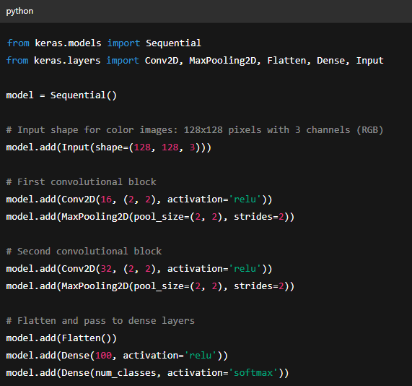**Conv2D:** Applies filters to extract features from images.

**MaxPooling2D:** Reduces spatial size and adds spatial invariance.

**Flatten:** Converts 3D feature maps to 1D vector.

**Dense**: Learns class-specific patterns and outputs final predictions.

### ✅Takeaways

✅ CNNs are optimized for processing **image data** using a **layered structure** of convolutions, activations, pooling, and dense layers.

✅ The architecture:

* Preserves spatial structure
* Reduces the number of parameters
* Extracts hierarchical features

✅ CNNs are the go-to architecture for solving complex **computer vision problems** like classification, object detection, and segmentation.

✅ Keras provides a clean and modular way to define CNNs using Conv2D, MaxPooling2D, Flatten, and Dense layers.

## 📌Recurrent Neural Networks (RNNs)

### 🔹What Are RNNs?

Traditional neural networks treat each input data point as **independent** of the others. This assumption works well for tasks like image classification or tabular data, but fails for any problem where **sequence and order matter**.

For example:

* Understanding a sentence in natural language.
* Predicting stock prices based on prior days.
* Analyzing audio or video streams.

In such cases, the context provided by **previous inputs** is essential. This is where **Recurrent Neural Networks (RNNs)** come in.

**Recurrent Neural Networks (RNNs)** are a type of neural network architecture specifically designed to handle **sequential or time-series data**.

**✅ Key difference:**

RNNs process inputs **one at a time**, maintaining an internal **state** (or memory) that reflects previous inputs. Each step in the sequence considers both:

* The **current input**
* The **output or hidden state from the previous step**

This creates a **loop** within the architecture, allowing the network to build **temporal dependencies** between data points.

### 🔹RNN Architecture

The key architectural idea is that the **output from a previous time step is fed back into the network** along with the current input.

Let’s walk through the architecture based on the diagram:

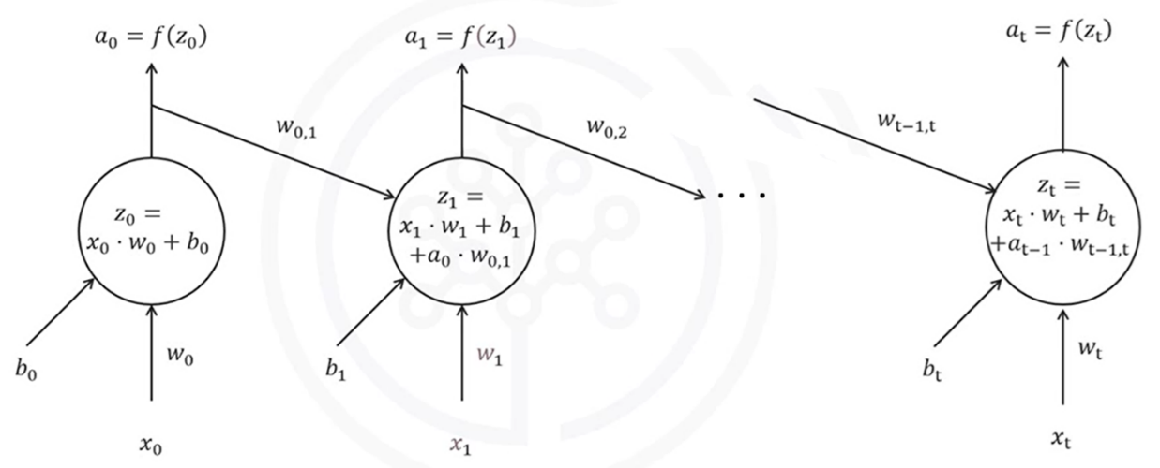

|  |  |
| --- | --- |
| **🧩Notation $x_{t}$**   * : Input at time step t. $z_{t}$* : Weighted sum (pre-activation) at time step t. $a_{t}$* : Activation (output) at time step t. $w_{t}$* : Weight matrix for input xₜ. $w_{t-1, t}$* : Weight matrix for previous activation $a_{t-1}$. $b_{t}$* : Bias term at time step t $f(..)$* : Activation function (e.g., tanh or ReLU). | **🧠How the RNN Processes Sequences**  At each time step t, the RNN performs the following operations:   1. Receives the current input . 2. Receives the previous output $a_{t-1}$ (activation from the previous time step). 3. Computes a weighted sum: 4. Applies the activation function to produce the output: 5. Passes aₜ to the next time step. |

This process repeats for each element in the sequence, preserving temporal relationships across steps.

**🔁Time-Unrolled Architecture**

The RNN can be "unrolled" across time steps to visualize how it processes sequences. Each copy of the network at time t:

* Has its **own input $x_{t}$**
* Shares weights across all steps
* Passes its activation forward to the next step

Here’s what happens step-by-step:

* **At time step t=0**:
  + The network receives input $x_{0}$.
  + Computes: $z_{0}=x_{0}*w_{0}+b_{0}$
  + Applies activation: $a_{0}=f(z_{0})$
* **At time step t=1**:
  + Receives $x_{1}$ and $a_{0}$ as inputs.
  + Computes: $z_{1}=x_{1}*w_{1}+b_{1}+a_{0}*w_{0,1}$
  + Applies activation: $a_{1}=f(z_{1})$
* **At time step t**:
  + Receives and $a_{t-1}$.
  + Computes: $z_{t}=x_{t}*w_{t}+b_{t}+a_{t-1}*w_{t-1,t}$
  + Applies activation: $a_{t}=f(z_{t})$

This chaining of activations makes it possible to retain context over time — unlike standard feedforward networks.

### 🔹Common Use Cases

RNNs are suitable for any task involving ordered data:

| **Use Case** | **Description** |
| --- | --- |
| Natural Language Processing (NLP) | Sentiment analysis, translation, text generation |
| Time Series Forecasting | Stock prices, weather, sales prediction |
| Genomic Sequence Modeling | Predicting genetic features from DNA/RNA sequences |
| Audio Processing | Speech recognition, music generation |
| Handwriting Generation | Modeling the sequence of pen strokes |

### 🔹Why RNN Architecture Works

* The **feedback loop** allows the model to accumulate knowledge across steps.
* **Shared weights** reduce the number of parameters and help generalization.
* The structure naturally models **ordered data** (e.g., language, audio, video, sequences).

⚠️ However, traditional RNNs struggle to retain information over long sequences due to the **vanishing gradient problem**. This led to the development of more advanced architectures like **LSTM (Long Short-Term Memory) model**, which include gating mechanisms to better manage memory.

### 🔹Long Short-Term Memory – A Specialized RNN

A key challenge with standard RNNs is the **vanishing gradient problem**, which makes it difficult to learn long-range dependencies across time steps.

To solve this, **Long Short-Term Memory (LSTM)** units were introduced.

**✅ LSTMs use:**

* **Gating mechanisms** to control what to remember, forget, and output at each step.
* Internal **memory cells** that store relevant past information across long sequences.

Because of this, LSTMs have become the most widely used RNN variant.

🔧 **LSTMs Applications:**

LSTM models have been successfully used in several advanced deep learning applications:

* **Image Generation**: Sequentially generating pixels conditioned on prior ones.
* **Handwriting Generation**: Modeling realistic sequences of handwritten text.
* **Image Captioning**: Generating natural language descriptions for images.
* **Video Description**: Producing textual summaries of video sequences.

### ✅Takeaways

✅ Standard neural networks treat all data points independently, which limits their use in sequential tasks.

✅ **Recurrent Neural Networks (RNNs)** introduce feedback loops, enabling them to retain memory of past inputs and learn temporal relationships.

✅ **LSTMs** are a more powerful and stable variant of RNNs, designed to capture **long-term dependencies** without suffering from vanishing gradients.

✅ RNNs (and LSTMs) are foundational for tasks involving **language, audio, sequential data**, and **temporal reasoning**.

## 📌Transformers

**Transformers** are a type of neural network architecture that has fundamentally transformed the field of **Natural Language Processing (NLP)** and beyond. Unlike RNNs or CNNs, which rely on processing data sequentially or in spatial chunks, transformers are capable of modeling **long-range dependencies** in data efficiently — and **in parallel**.

They are the foundation behind some of the most powerful AI tools today, including:

* **ChatGPT, Gemini** (based on Generative Pretrained Transformers)
* **BERT** (used in Google Search and Translate)
* **DALL·E** and **image transformers** (used for text-to-image synthesis in tools like Adobe Photoshop)

### 🔹The Attention Mechanism

The key breakthrough that enables transformers to outperform previous models is the **attention mechanism**, particularly **self-attention** and **cross-attention**.

This mechanism allows the network to **evaluate relationships between input tokens**, weighting the importance of each part of a sequence **relative to every other part**. As a result, the model captures **global context** more effectively than traditional architectures.

### 🔹Self-Attention Mechanism (for Text)

The transformers use a self-attention mechanism to process textual data.

The **self-attention mechanism** enables a model to contextualize a token (word, character, etc.) by attending to other tokens in the same input sequence. It consists of three major components:

* 1. **Query, Key, and Value Vectors (Q, K, V)**

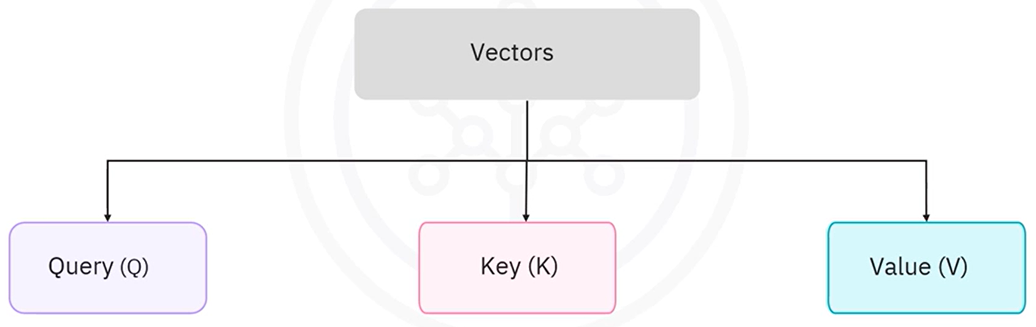

For each input token, the model creates three vectors:

* **Query (Q):** Represents the current token being processed. Is used to ask: “Which other words are important to me?”.
* **Key (K):** Represents all tokens being compared against. Each word’s identity.
* **Value (V):** Carries the actual information to be passed forward to next layer.

Each of these vectors is obtained through linear projections from the token embeddings.

* 1. **Attention Scores**

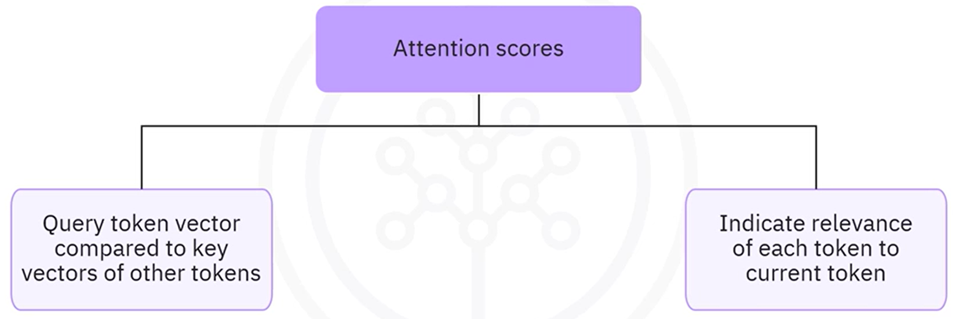

* The **attention score** is computed using the **dot product** between the query vector of the current token and the key vectors of all tokens in the sequence.
* These raw scores indicate **how relevant** other tokens are to the current one

1. **Weighted Sum**

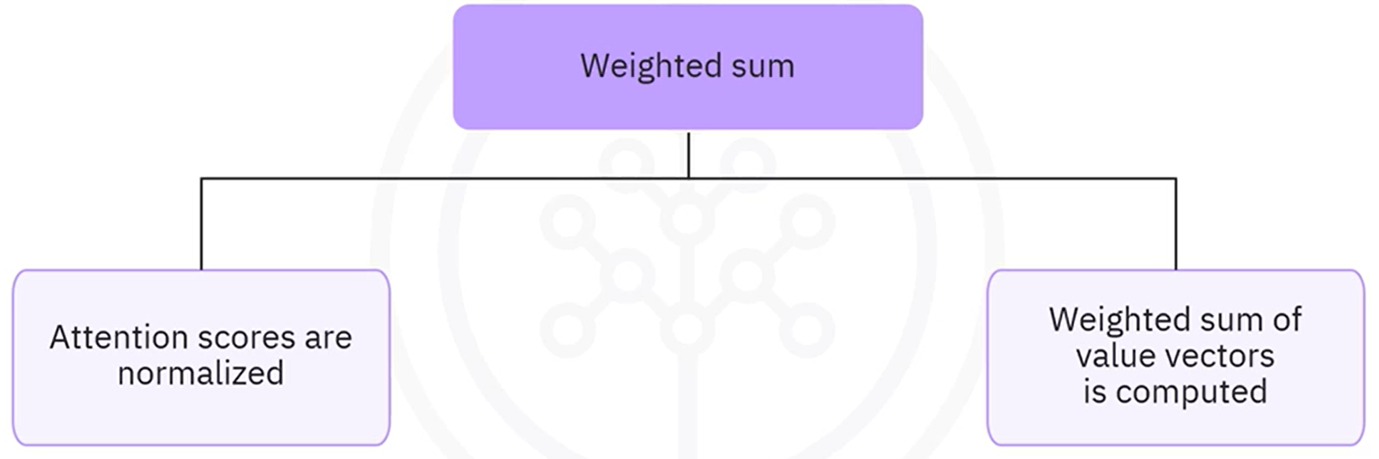

* The scores are scaled and passed through a **softmax function** to generate normalized attention weights (probabilities).
* A **weighted sum** of the value vectors is computed based on these attention scores.
* This results in a **context vector** for each token that captures global information from the sequence.

The final contextual embeddings are passed to the next layer, enabling deep modeling of sentence-level semantics.

#### ⚙️ Example of Self-Attention

For the sentence -> **"The dog runs"**

* 1. Each word is first converted into an **embedding vector**.

**Input tokens** are first converted into **dense vectors**, also known as **embeddings**. These embeddings are numerical representations that capture the meaning and relationships between words.

Embeddings are **learned** during training via backpropagation, each word has a **unique embedding vector.**

Each token is mapped to a fixed-size vector

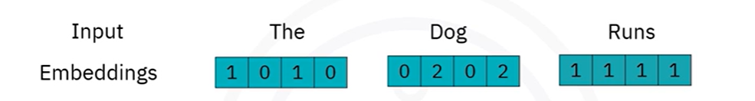

* 1. **Positional encoding**

Since transformers don’t have recurrence, they don’t inherently know the **order** of tokens. To add order information, a **positional vector** is added to each token’s embedding.

Resulting vector = **Word embedding + Positional encoding**

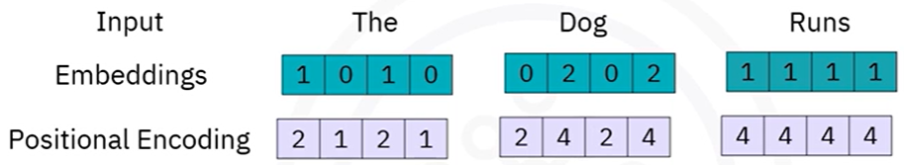

Position-aware input vectors:

* "The" = [1 0 1 0] + [2 1 2 1] = [3, 1, 3, 1]
* "Dog" = [0 2 0 2] + [2 4 2 4] = [2, 6, 2, 6]
* "Runs" = [1 1 1 1] + [4 4 4 4] = [5, 5, 5, 5]
  1. Q, K, and V vectors are generated from each embedding, by:

Applying **separate linear transformations** (matrices) to each token's embedding.

Each transformation is **learned during training**, specific to the attention head.

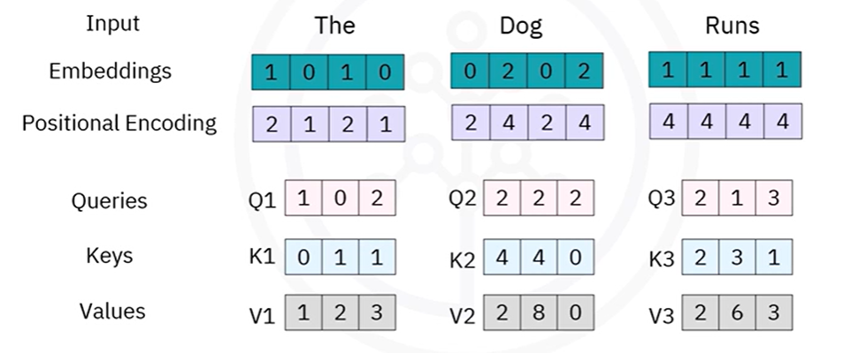

Each word's combined embedding (after positional encoding) is passed through **three different weight matrices** to produce:

* Query vector (Q) -> $Q=E*W^{Q}$
* Key vector (K) -> $K=E*W^{K}$
* Value vector (V) -> $V=E*W^{V}$

Where:

* **E** is the [word + position] embedding
* $W^{Q}, W^{K}, W^{V}$ are **learnable weight matrices** (different for Q, K, V)
* Output dimensions can be chosen (e.g., 4D → 4D)
  1. Attention scores are computed for each token pair using the **dot product** of Query and Key vectors -> $Q*K^{t}$

Each **row corresponds to a Query** and each **column to a Key**.

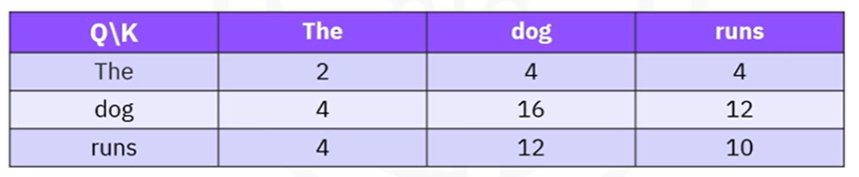

This table tells us:

1. The **query for "Dog"** gives **highest relevance to itself (16)**.
2. The **query for "Runs"** is most related to "Dog" (12), then "Runs" (10), then "The" (4).
3. These raw attention scores will be **normalized via softmax** in the next step.
4. Softmax normalization is applied to generate weights, Converting Attention Scores into probabilities

This produces a **probability distribution** over the tokens, summing to 1, for example:

* The: 0.05
* Dog: 0.65
* Runs: 0.30

These are called the **attention weights** — they determine *how much each token contributes to the current token’s final representation*.

1. Weighted sums of the Value (V) vectors with the **attention weights**,addingcontext-aware embeddings.

This gives us the **output vector for the current word**, now enriched with contextual information from other tokens.

ℹ️ In **self-attention**, each token (or word) in the input sequence generates its **own probability distribution** over **all tokens**, including itself.

Example, using token “**dog**”:

* + - * Vectors are:
        + The -> [1, 2, 3]
        + Dog -> [2, 8, 0]
        + Runs -> [2, 6, 3]
      * Probability distribution for “dog” token -> [0.05, 0.65, 0.3]
      * Compute the new embedding:

$$Output_{\text{"dog"}}=0.05*V_{1}+0.65*V_{2}+0.30*V_{3} \\ =0.05*\left[1, 2, 3\right]+0.65*\left[2, 8, 0\right]+0.30*\left[2, 6, 3\right] \\ =[1.95, 7.10, 1.05]$$

This new vector is the **contextual embedding for the word "Dog"** — it captures not just the word itself, but also the influence of surrounding words like "The" and "Runs".

### 🔹Cross-Attention Mechanism (for Text-to-Image)

Transformers are also extensively used for **text-to-image generation**, which is made possible through another form of attention known as the **cross-attention mechanism**.

While self-attention focuses on understanding relationships within a **single sequence** (like a sentence), **cross-attention allows one type of input to influence another**, such as using a text prompt to guide image generation.

Cross-attention works in **three main phases**, building on the contextual understanding created during self-attention.

* 1. Learning Contextualized Embeddings with Self-Attention.

Given a natural language prompt such as:

*"A two-story house with a red roof and a garden in front"*

The transformer model first uses a **self-attention mechanism** to learn contextualized embeddings from the entire sentence. Each word in the prompt is processed in the context of the other words, resulting in a **sequence of embeddings** that represent the full semantic meaning of the sentence.

These embeddings are passed through a **transformer encoder**, which produces a set of **Query vectors (Q)** representing the textual input.

* 1. Applying Cross-Attention for Image Generation.

Next, the transformer model responsible for **image generation** (e.g., **DALL·E**) takes over. It uses the **Query vectors from the text encoder** and performs a **cross-attention operation** setup to determine **how the text prompt should influence the visual output**., with its own internal image tokens.

In this mechanism:

* The **Query (Q)** comes from the **textual input**.
* The **Keys (K)** and **Values (V)** are derived from **image representations** or partially generated image data.
  1. Applying Cross-Attention for Image Generation.

The image is generated **sequentially** using an **auto-regressive approach**:

* At each generation step, the model predicts the **next part of the image**.
* The prediction is based on:
  + The **text prompt (via Q from cross-attention)**
  + The **previously generated image parts**

This allows the model to **compose an image piece-by-piece**, guided by the meaning of the original text.

The output image is **synthesized from scratch** based on the model’s learned understanding of text-image relationships.

This enables the model to:

* Combine **concepts that may not exist in the real world**
* Create **whimsical or creative combinations**
* Generate **multiple variations** of the same prompt, allowing for creative exploration

### 🔹Transformers vs RNNs

While both **Transformers** and **Recurrent Neural Networks (RNNs)** are used for processing sequential data, they differ significantly in how they handle sequences — especially in terms of performance, scalability, and ability to capture long-range dependencies.

| **Feature** | **RNNs** | **Transformers** |
| --- | --- | --- |
| Data Processing | Sequential (step-by-step) | Parallel (entire sequence at once) |
| Training Speed | Slower (not parallelizable) | Faster (fully parallelizable) |
| Dependency Modeling | Short-term dependencies | Long-range dependencies |
| Vanishing Gradient Risk | High (especially in long sequences) | Mitigated via attention |
| Suitability | Simple or short-sequence tasks | Complex, long-context tasks (NLP, vision) |

### 🔹Limitations of Transformers

Despite their capabilities, transformers also present certain challenges:

* **Data Hungry**: Require large volumes of training data to generalize well.
* **Bias Amplification**: Because learning is purely data-driven, **biases present in training data** can be embedded and perpetuated.
* **Resource Intensive**: Training and inference with large transformer models demand **significant computational resources**.

These limitations have motivated ongoing research into more efficient and responsible variants of transformer models.

### ✅Takeaways

✅ Transformers are a type of neural network architecture designed to handle sequential data using attention mechanisms instead of recurrence.

✅ The **self-attention mechanism** allows each token in a sequence to focus on other tokens, capturing long-range dependencies more effectively than RNNs.

✅ Transformers process data **in parallel**, enabling significantly faster training compared to RNNs, which handle data sequentially.

✅ The **cross-attention mechanism** enables multimodal generation tasks, such as producing images based on text descriptions.

✅ Unlike models that retrieve stored content, transformers can synthesize **entirely new outputs** based on their understanding of the input (e.g., text-to-image generation).

✅ Despite their strengths, transformers require **large datasets** and can **inherit biases** from the data they are trained on.

✅ Transformers are now the backbone of state-of-the-art systems in NLP and generative AI, powering models like ChatGPT, BERT, and DALL·E.

## 📌Autoencoders

**Autoencoders** belong to the realm of **unsupervised learning**. These models are not trained with labeled outputs. Instead, their objective is to **reconstruct their input** as accurately as possible — learning useful internal representations along the way.

An autoencoder is essentially a **neural network that compresses data and then reconstructs it**. Unlike manually engineered compression algorithms, autoencoders **learn the compression and decompression functions directly from data**.

### 🔹What Is Autoencoding?

**Autoencoding** is a form of **data compression** where the input is encoded into a lower-dimensional representation, and then decoded back to its original form.

* The process is **data-specific**, meaning the model learns features tailored to the kind of data it was trained on.
* For example, an autoencoder trained on **car images** will learn features relevant to vehicles and will likely perform poorly on **building images**.

### 🔹Architecture of an Autoencoder

Autoencoders are composed of three key parts:

* **Encoder** -> Compress the input into a **compact, latent representation**.
* **Bottleneck / Latent Space** -> Represents the most **informative feature** in compressed form.
* **Decoder** -> Reconstructs the input from the latent representation.

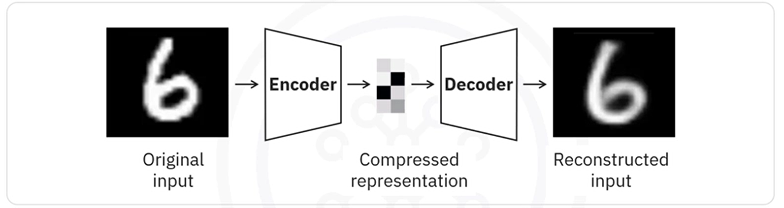

The network is trained to **minimize reconstruction error** between the input and the output, often using mean squared error (MSE) loss.

**How it works:**

* Input: e.g., an image
* The encoder compresses the image into fewer dimensions
* The decoder tries to **reconstruct the original image** from this compressed data
* Training is done using **backpropagation**, just like other neural networks
* The target variable is set equal to the input

### 🔹Why Use Autoencoders?

Unlike techniques like PCA that are limited to linear transformations, autoencoders can learn **nonlinear feature mappings** due to their use of **activation functions**, such as ReLU or sigmoid.

**Key applications:**

* **Data denoising**: Removing noise from corrupted inputs
* **Dimensionality reduction**: For visualization or compression
* **Anomaly detection**: Poor reconstruction indicates unfamiliar or abnormal input
* **Pretraining**: Learning features before fine-tuning on a supervised task

### 🔹Restricted Boltzmann Machines (RBMs)

A popular and early form of autoencoder is the **Restricted Boltzmann Machine (RBM)** — a stochastic, generative neural network.

RBMs consist of two layers:

* A **visible layer** (input)
* A **hidden layer** (learns features)

The connection is undirected and **no connections exist within a layer**, hence the term "restricted".

Successful applications:

* **Handling imbalanced datasets**:

They can learn the distribution of the minority class and generate new synthetic samples to balance the dataset.

* **Missing data imputation**:

RBMs can predict or estimate missing values based on learned relationships.

* **Automatic feature extraction**:

Especially useful for **unstructured data**, where traditional methods struggle to identify relevant features.

### ✅Takeaways

✅ Autoencoders are unsupervised deep learning models that **compress and reconstruct data** by learning internal representations.

✅ The architecture consists of an **encoder**, a **latent space**, and a **decoder**.

✅ Autoencoders are **data-specific**, meaning their effectiveness depends on similarity between training and input data.

✅ They are useful for tasks like **denoising**, **dimensionality reduction**, and **unsupervised feature learning**.

✅ **Restricted Boltzmann Machines (RBMs)** are an early type of autoencoder used for **feature extraction**, **handling imbalanced datasets**, and **estimating missing values**.

## 📌Using Pre-trained Models

**Pre-trained models** are deep learning models that have already been trained on large datasets (such as ImageNet). Rather than training a model from scratch, you can **reuse these models as powerful feature extractors** or **fine-tune them for new tasks**.

This approach falls under the umbrella of **transfer learning**, where knowledge gained from one task is leveraged to solve a different, but related, task — often with less data and less computation.

Instead of fine-tuning these models for new tasks, **we can use them directly as feature extractors**.

This approach involves using the pretrained model to extract high-level features from new data, which can then be used for various downstream tasks without additional training.

For example, ImageNet trained models like VGG16 or ResNet are used to extract feature maps from images that can be applied in tasks, such as clustering, visualization, or feeding into simpler machine learning models.

**How it works:**

* Load a model like **VGG16** or **ResNet**, pretrained on ImageNet.
* **Exclude the top layers** (the classifier).
* Feed in new images to obtain **feature representations** (also called feature maps).
* These features can then be used for:
  + **Clustering**
  + **Data visualization**
  + **Input to simpler machine learning models**

This method is beneficial when you want to utilize the powerful feature extraction capabilities of these models without modifying the original weights through retraining.

### 🔹Benefits of Using Pre-trained Models

🧠 **No additional training required**

Extract features without modifying the model’s weights.

**⚡ Fast implementation**

Quick to deploy and requires minimal compute resources.

**🎯 Efficient feature reuse**

Leverages rich, hierarchical features learned from large-scale data.

**💡 Suitable for small datasets**

Ideal when you don’t have enough data to train a model from scratch.

The network is trained to **minimize reconstruction error** between the input and the output, often using mean squared error (MSE) loss.

### 🔹How to use Pre-trained Models for Feature Extraction in Keras

Let's see how to use a pretrained model in Keras specifically for feature extraction.

We will load a pretrained model such as VGG16 and use it to extract features from a new dataset without any additional training.

First, we need to create the sample data:

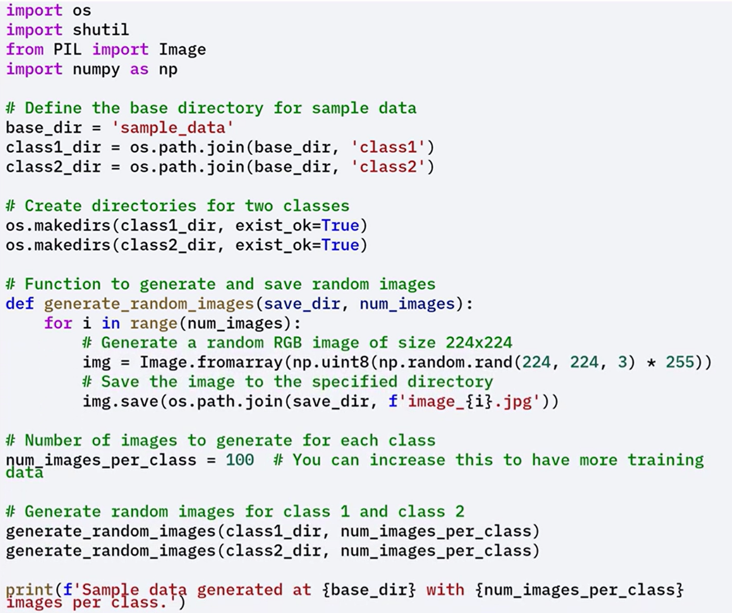



This example demonstrates how to use pretrained models strictly for extracting features that can be applied to downstream tasks like clustering, visualization, or dimensionality reduction.

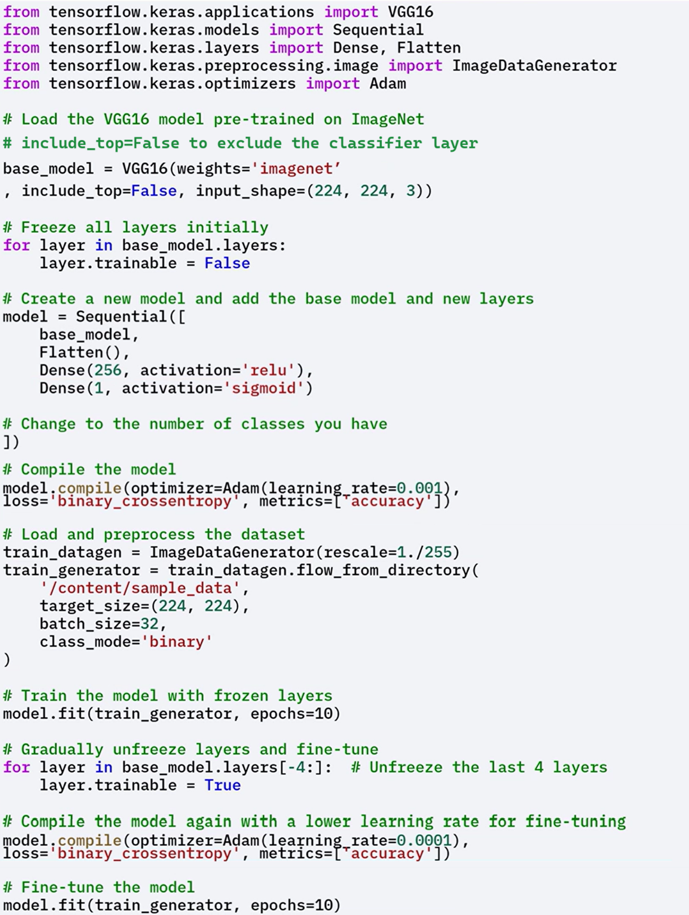



This step-by-step process demonstrates how easy it is to integrate pretrained models into your workflow using Keras.

By doing so, you can leverage the powerful feature extraction capabilities of models like VGG16, which have been trained on extensive datasets.

### 🔹Fine-Tuning Pre-trained Models

**Fine-tuning** is the process of **partially retraining a pre-trained model** to adapt it more closely to a **new task or dataset**.

* **Unfreezing some of the top layers** of the base model.
* Training them alongside the newly added layers.

This allows the model to better adapt to the **specific features of the new dataset**, improving performance further and customizing the model for the specific use-case.

**Why Fine-Tune:**

* The **new dataset is different** from the dataset used to train the original model.
* You **don't have enough data** to train a full deep model from scratch.
* You want to **boost performance** beyond what frozen features can offer.

**When to fine-tune:**

* Your dataset is **somewhat different** from the original (e.g., medical images vs. natural images).
* You want the model to adjust learned features to **better match the new task**.

This process is more flexible than using a frozen model and is a core concept in **transfer learning**.

### ✅ Takeaways

✅ Pre-trained models like **VGG16** and **ResNet** can be used directly as feature extractors without training.

✅ This approach is ideal for scenarios with **limited data** or **limited computing resources**.

✅ Pre-trained convolutional layers capture **rich hierarchical features** that are transferable to new tasks.

✅ **Fine-tuning** enables you to adapt a pre-trained model to your dataset by unfreezing and retraining select layers.

✅ Using pre-trained models in Keras makes it easy to integrate **deep feature learning** into any workflow.

# INDEX

⚡***Module 1 - Introduction to Deep Learning and Neural Networks*** 1

📌**Introduction to Deep Learning** 1

🔹Real-World Applications of Deep Learning 1

🔹Additional Notable Use Cases 2

📌**Neurons and Neural Networks** 2

🔹Biological Neurons: Structure and Function 2

🔹Learning in Biological Neural Networks 3

🔹Artificial Neurons: Modeled Behavior 3

📌**Artificial Neural Networks** 4

🔹Foundations of Neural Networks 4

🔹The Perceptron: Mathematical Formulation 5

🔹Activation Functions and Their Role 6

🔹Forward Propagation in Detail 7

⚡***Module 2 - Deep Learning Fundamentals*** 9

📌**Gradient Descent** 9

🔹Understanding the Cost Function 9

🔹What is Gradient Descent? 10

🔹Gradient Descent Formula 10

🔹Behavior Around the Minimum 11

🔹Visualizing the Iterative Optimization 11

📌**Backpropagation** 13

🔹What Is Backpropagation? 13

🔹The Role of Backpropagation in Training 13

📌**Vanishing Gradient** 17

🔹The Vanishing Gradient Problem: Overview 17

🔹How Gradients Disappear 18

📌**Activation Functions** 19

🔹Role of Activation Functions in Neural Networks 19

🔹Limitations of the Sigmoid Function 19

🔹Commonly Used Activation Functions 20

🔹Practical Guidelines for Activation Function Choice 23

⚡***Module 3 - Keras and Deep Learning Libraries*** 24

📌**Deep Learning Libraries** 24

🔹Overview of Major Libraries 24

🔹Summary of Comparison 26

📌**Regression Models with Keras** 26

🔹Building the Network Architecture 27

🔹Using Keras to Define the Model 27

📌**Classification Models with Keras** 29

⚡**Module 4 - Deep Learning Models** 32

📌**Shallow vs Deep Neural Networks** 32

🔹Differences Between Shallow and Deep Networks 32

🔹Why Deep Learning Took Off 32

📌**Dropout and Batch Normalization** 34

🔹Dropout Layers 34

🔹Batch Normalization 34

📌**Convolutional Neural Networks** 35

🔹Key Characteristics of CNNs 35

🔹CNN Architecture Breakdown 36

🔹Complete Flow of CNN Layers 40

🔹Building a CNN in Keras 40

📌**Recurrent Neural Networks (RNNs)** 41

🔹What Are RNNs? 41

🔹RNN Architecture 42

🔹Common Use Cases 43

🔹Why RNN Architecture Works 44

🔹Long Short-Term Memory – A Specialized RNN 44

📌**Transformers** 45

🔹The Attention Mechanism 45

🔹Self-Attention Mechanism (for Text) 46

🔹Cross-Attention Mechanism (for Text-to-Image) 50

🔹Transformers vs RNNs 51

🔹Limitations of Transformers 52

📌**Autoencoders** 52

🔹What Is Autoencoding? 53

🔹Architecture of an Autoencoder 53

🔹Why Use Autoencoders? 53

🔹Restricted Boltzmann Machines (RBMs) 54

📌**Using Pre-trained Models** 55

🔹Benefits of Using Pre-trained Models 55

🔹How to use Pre-trained Models for Feature Extraction in Keras 56

🔹Fine-Tuning Pre-trained Models 58

Course 2

Introduction to Deep Learning & Neural Networks with Keras